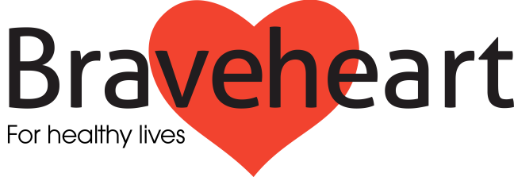
Volunteer Feedback Form

Six months ago you began your involvement as a volunteer (Walk Leader/Health Mentor/Fundraiser) with The Braveheart Association.
We invite you to share your experience, to identify your goals for the next six months, and to comment on how you are involved and supported by Braveheart. This will enable us to review the support we give you and highlight your further support or training needs.
Please find below questions, which your Development Officer would like to discuss at your feedback session. Please feel free to note down your comments bringing them along on the day.
All information given is filed and secured as confidential.
In relation to your volunteering with Braveheart over the past six months:

- What have you enjoyed the most?

- What have you enjoyed least and could Braveheart have helped?

- What goals do you have for the next six months?

- Are you happy with the time commitment you agreed to six months ago?

- Would you like to propose any changes to your volunteering? If so what are they?

- Do you have any training needs you’d like us to address? If so, what are they?

- Please comment on your volunteering experience with regards to your initial expectations.

- Any other comments or questions?

- Comments from Development Officer

Signed……………………………………….. (Volunteer) Date………………………….

Signed……………………………………….. (Named Contact) Date………………………….

Please return to:
The Braveheart Association
Falkirk Community Hospital
Majors Loan, Falkirk
FK1 5QE

