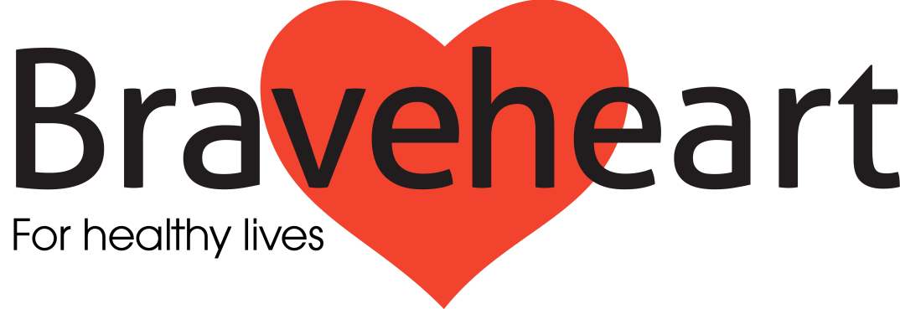

The Braveheart Association’s 2015 Consultation Project Report

The Braveheart Association Board would like to thank all those who were involved in our 2015 consultation project. We very much appreciate the contribution of all those who completed questionnaires or participated in focus groups and discussion. This report outlines our main findings.

Why did we do it?
Our aim was to gather the views and opinions of all our partners and those who are, or who have been involved with the organisation in the past. We hoped that our findings would help us recognise what we do well, what we might be able to do better and in particular to help us with planning the future direction of the organisation.

Who took part and how?
Our consultation project saw over 100 people engage with Braveheart. We ran 5 focus groups which included volunteers, staff and Board members. Service users were involved in some of these, with their views also being recorded in questionnaire format. Liaison and partnership working with the NHS and other voluntary sector organisations is considered important for Braveheart’s future and hence the project saw us consult with NHS Forth Valley, Falkirk Local Medical Committee, local general practitioners and Falkirk Council for Voluntary Services (CVS).

What did we find out?
The results of our consultation are outlined below.
- How do people describe what Braveheart does?
Our volunteers, staff, Board members and service users provided a clear consensus in their answer to this question. People described Braveheart as an organisation which aims to promote health and wellbeing by encouraging exercise, providing mentor support, sensible lifestyle advice and also by addressing social isolation through the building of peer support and friendship. Conversely it was apparent that some of our NHS partners were less well informed about the existence of Braveheart, its aims and objectives.

When our walkers and long-term condition group attendees were asked to rate Braveheart on a scale from ‘not very good’ to ‘excellent’, no-one rated the organisation below ‘good’ with 95% of walkers selecting either ‘very good’, ‘excellent’ or both of these categories.
“It is an organisation that promotes health, wellbeing and is very sociable”
(Quotation from a Braveheart walker)
“(It) puts you in touch with people who share the same condition and problems it brings”
(Quotation from a self-management group member)

- What are the most important things that Braveheart does?
The results of this question repeat many of the themes identified in question 1. Service users, volunteers and staff members highlighted that Braveheart helps people to socialise, get fitter, adopt a healthier lifestyle, share information and overall self-manage their long-term condition(s) and general health.

An NHS partner who is well informed about Braveheart and our activities suggested that in their view the opportunity for peer support, increased knowledge and networking were most important. Falkirk CVS reported that supporting people in the self-management of long-term conditions was our most vital role.

“Braveheart walks are not only good for you, it is also a social time as well. The camaraderie and friendship of other walkers like yourself takes away the feeling of loneliness for some”
(Quotation from a Braveheart walker)

“Meetings encourage healthy eating and promote healthy lifestyle”
(Quotation from a self-management group member)
- How could Braveheart improve what it currently does?
Whilst there were some suggestions on how we might improve what we do, the focus of the feedback was on improving the communication of what is currently available. Improving our community, NHS and voluntary sector links was a common theme which emerged through feedback from people within all of the different groups with whom we engaged. Many people suggested that this would help to improve the local awareness and visibility of Braveheart, promote referrals to our services, assist with fundraising, help with community support and involvement and also potentially lead to Braveheart services being rolled out on a wider scale. It was noted by many people that improving our advertising, marketing and communication policies may help in this endeavour.
- What could Braveheart do differently in the future?
Many answers to this question reiterated the views which were shared in the previous question – namely awareness raising, improving our publicity, ensuring a continuous programme of volunteer recruitment, working more closely with the NHS, offering other exercise programmes and improved partnership working. Additionally, responses from a number of different sources, including the NHS, suggested that we consider developing some services specifically for those with other medical problems, such as those with respiratory problems or those with mental health issues.

The potential problem of adult loneliness in the community was also highlighted through the results. It was acknowledged that Braveheart does and should continue to recognise that it can help to alleviate this. We could perhaps build services specifically to tackle social isolation.
- Would people be prepared to contribute to the services that Braveheart offers?
Our service users and volunteers almost unanimously reported that they felt that our services should remain free. However, in recognition of the cost of providing transport to walking activities, many people indicated that they would like to have the opportunity to make a voluntary donation towards the running of the organisation.
What next?

The Board are extremely happy that amongst those people who have had any direct contact with the organisation, respondents were clear about Braveheart’s purpose, current services and that there appears to be a good appreciation of Braveheart’s activities. There was also clear recognition of the social benefits of peer support and group activity participation, which can improve one’s feeling of wellbeing. This element of Braveheart was seen to feature alongside our more overt health related educational focus.
In contrast, amongst those people who have little direct contact with Braveheart, there was very limited understanding of the services that we offer. This was particularly apparent amongst healthcare professionals working in primary care, with whom there is the potential to build mutually beneficial relationships over future years.
The main areas to consider for future development are:

- Extending the reach of Braveheart, we do what we do well and others would benefit from it too
- Working more closely with other organisations to increase the access to our services. This could include core NHS services
- Improving advertising and marketing of what we do to increase the awareness of Braveheart amongst the NHS and wider community
- Reviewing the way we evaluate our services, making sure we deliver value for money
- Continuous improvement of communication within Braveheart and with others outside the organisation
- Address sources of long term funding.

The Board are in the process of developing a five year plan for Braveheart which will outline our vision for the organisation’s future. Your contributions will impact significantly upon our strategic direction for the coming years.
The consultation process has highlighted the value of communication with all those involved with Braveheart, and we would like to this to continue. If you have any further feedback or suggestions please do not hesitate to get in touch. We will always value your feedback.
Most importantly we hope that Braveheart is an organisation which can continue to serve you and the local community effectively, by promoting health and wellbeing through a range of projects, groups and activities.

Thank you,
From The Braveheart Association Board
May 2015

Please follow what we are doing on facebook or visit our website:
https://www.facebook.com/braveheartfalkirk
http://www.braveheart.uk.net/

