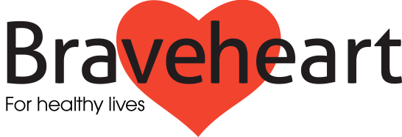

The Braveheart Association
Membership Form
Please note copies of the constitution and this membership form are available on request from:
The Secretary,
The Braveheart Association, Falkirk Community Hospital,
Major's Loan Falkirk, FK1 5QE.
Members details:
name:
E MAIL / Contact Address:
postcode:
telephone:
Email:
Please ensure your email address is accurate as we intend to use this as our preferred means of communication. If you don't have an email address, we will post information to you.

Please note the following points on becoming a member:
- We will not share your personal details with any other organisation and we will only use the information provided to communicate with you on matters relating to The Braveheart Association.
- The members of the organisation have no liability to pay any sums to help to meet the debts (or other liabilities) of the organisation if it is wound up; accordingly, if the organisation is unable to meet its debts, the members will not be held responsible.
- The members and charity trustees have certain legal duties under the Charities and Trustee Investment (Scotland) Act 2005; and point 2 above does not exclude (or limit) any personal liabilities they might incur if they are in breach of those duties or in breach of other legal obligations or duties that apply to them personally.

Membership is open to any individual over 16 years of age who subscribes to the objects of the Braveheart Association. The objects of the organisation are given below and can be seen in clause 4 of the constitution. Copies of the constitution can be seen in full on the website under the “About Us” section: http://www.braveheart.uk.net/
The Objects of the Association shall be to provide a framework of active support and encouragement for adults with any long term condition and those at risk of developing a long term condition and, to promote their current and future wellbeing.
Membership is not transferrable.

Signed……………………………………………………………………….

