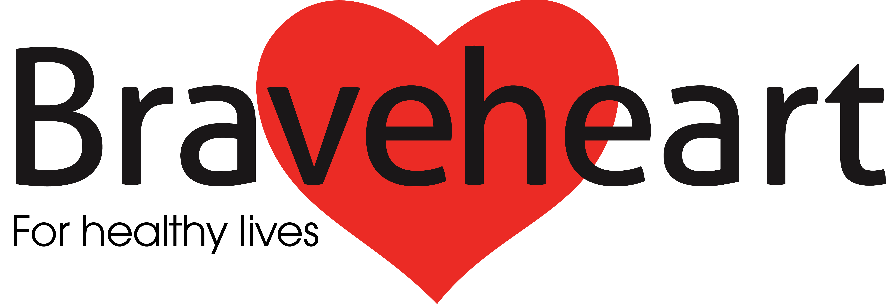[](http://www.google.co.uk/url?url=http://www.pixographia.com/greeting-cards/&rct=j&frm=1&q=&esrc=s&sa=U&ved=0ahUKEwjg84-esJrMAhWEMBoKHVz9A1g4eBDBbggwMA0&usg=AFQjCNHRBEOXegLcjMwihq4tDQF-X88TQQ)

**Braveheart’s**

**Spring Newsletter 2016**

**Braveheart has had a super start to 2016 with lots of exciting things going on, from walks to welcoming new Board members and from farewells to funding!**

**Braveheart’s next newsletter is due out in August 2016!**

***Walk with Braveheart***

Our walks have kicked started 2016 with 108 walks led & 1,344 attendances on walks from Jan-March alone! Our Monthly walks are fairly in the swing with a total of 132 walkers joining us in both Secret Falkirk, Canada Woods, Kennetpans & Cumbernauld; with many more to come!

Our night walks have bounced back with a bang! Super numbers on both our Polmont walk, Tuesdays 7-8pm (meeting outside bowling club) & The Helix Park, Thursdays 7-8pm (meeting in stadium car park). Great for those who want to get a spot of fresh air on a nice light night in spring & summer.

As of May time, after having

RNIB trained many of our Walk Leaders, we’re looking to welcome blind, partially sighted and deaf individuals on our walks.

Many of our Walk Leaders also had the chance to attend Safety Outdoors Training & Walking Development Officer Eva Finlayson has also trained 9 new Walk Leaders to link with Braveheart.

\*We are applying for funding to allow our walks to be Dementia Friendly\*

***Key updates***

Braveheart started the process of changing our legal form to become a Scottish Charity Incorporated Organisation (SCIO) about 18months ago. Those who attended the AGM in 2014 might remember when this was first discussed. As a SCIO we are better able to support the work we do and to protect employees and Board members. Well, this change was finally recognized by OSCR (Office of the Scottish Charity Regulator) in March of this year. Good news. As a result of this change, we are to keep a register of membership and we have been building the number of members over the last few months. This initiative continues, so if you are not yet a member but would like to become one, please download a membership form in the “Braveheart Documents” section of the website.

Fund raising continues to be a key activity for Braveheart, as it does for all charitable organisations. We recently submitted a bid for a major three year project that was sadly unsuccessful. However, in the same week we learnt that a smaller bid to further our mentoring programme for six months was successful. This will be a continuation of the work that Eva Asante has been doing. Unfortunately Eva is no longer available, so we are looking at alternative ways of developing this initiative.

An important development over the first few months of 2016 has been the addition of three new Board members. We have been running a “skeleton” Board for the best part of a year. However, following some specific activities to recruit new members for the board we now enjoy the contribution of Vicky Junik, Lorna McIntyre and John Holleran. All three new Board members come with considerable experience in the charity sector and I am sure will make a big difference. The Board will now be able to play a more active role in dealing with some of the priorities of the organisation. One of the first priorities was to put together a new funding sub-group to look at our funding strategy over the short and medium terms. As three new members join the board, unfortunately an existing member has had to take a step back due to increasing work commitments. Many of you will have met Clare Tucker either in the office or on a weekend walk. Clare has played a vital role as Secretary to the Board and we are all hoping this is only a temporary situation.

The first quarter of 2016 is now over and we understand better what lies ahead. We are now much better placed to meet some of those challenges with a strong and active Board. We all look forward to supporting our staff and volunteers in continuing to make a positive difference to the many people across Falkirk and Clacks whose lives we touch.

Photograph by Allan Ross

# **[IMG_9659](http://www.braveheart.uk.net/wp-content/uploads/2016/04/IMG_9659.jpg)**

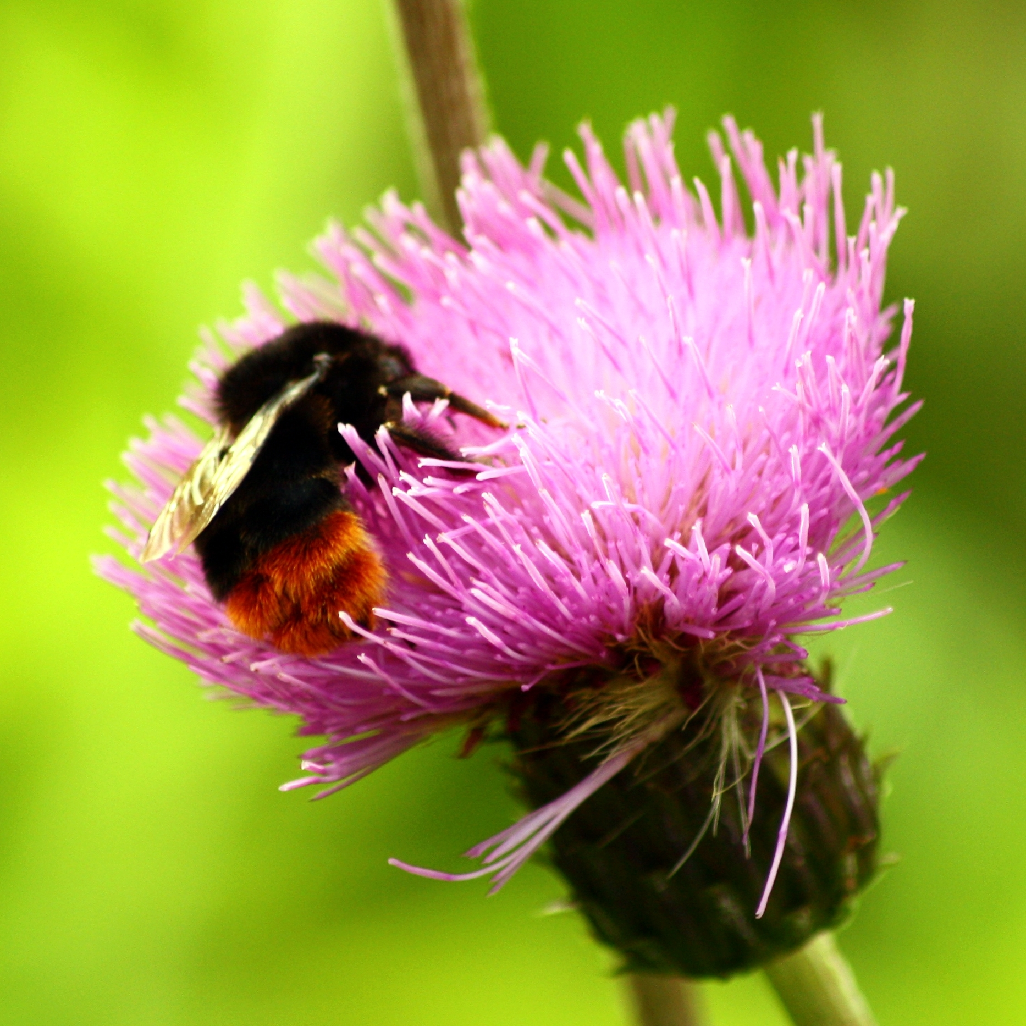

Please turn over…**** over…

# 

# ***Lose Weight With Braveheart***

Braveheart’s new healthy living programme is designed to support you plan a healthy diet and activity programme to help you take steps to your ideal weight. Our first Weight Management group ran in Falkirk Community Hospital from February 2016.

The pilot programme was a great success with participants losing 7.2 pounds on average and 2.5 inches from their waist!” Group members also commented on some of the changes they had made since joining the group,“This has changed our eating habits totally. No more crisps!”

Braveheart is working in partnership with the NHS “Choose To Lose” campaign, basing the programme on their healthy living materials, which are available on line. Braveheart groups are free of charge and provide the added benefits of Weight Management sessions where members can meet to learn and share experiences together, discuss the various healthy living topics and plan individual actions. A Braveheart group member pointed out the benefits of being in the group,

“I couldn’t have lost the weight on my own”. Braveheart is planning to run more Weight Management groups in the Falkirk area and we are taking names of people interested now. Trained Braveheart Health Mentors will facilitate the group sessions which will run weekly.

If you would like more information or to join a group, please contact Maureen Forbes, Braveheart Support Officer, on [Maureenforbes@nhs.net](mailto:Maureenforbes@nhs.net) or call her on 01324 673706.

# 

Feel free to contact Braveheart with suggested news for our next newsletter: 01324 673703

Do you know that Braveheart do talks to community groups; please get in touch if you’re interested: 01324 673703