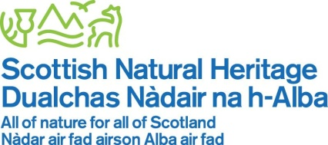
Walk With Braveheart
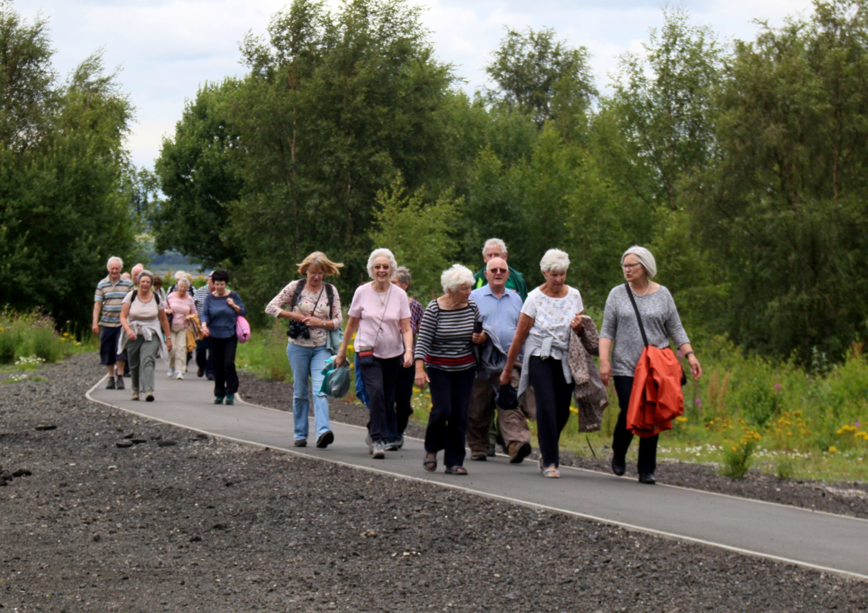
Evaluation Report For The Robertson Trust
October 2014 – June 2017

Table of Contents
Introduction
Year 1- October 2014- September 2015
What we achieved
The difference we made
Chosen targets moving forward

Year 2- October 2015- September 2016
What we achieved
The difference we made
Chosen targets moving forward

Year 3- October 2016- June 2017
What we achieved
The difference we made
Moving forward

Conclusion
Appendices

Introduction
From early beginnings as an Ageing Well Demonstration Project to examine the benefits of health mentoring in the area of cardiovascular disease, Braveheart developed into a thriving voluntary organisation supporting people with health conditions to live well.
The importance of keeping active for at least 30 minutes on most days of the week is well known, but people with health conditions can lose confidence and may be unsure how much activity is good for them and so Braveheart participants asked for a led walking programme.
Established in 2004, the walking programme successfully encouraged people with health conditions to take regular exercise, as the walks were designed specifically for their level of fitness and pace. Walkers felt comfortable, they formed friendships, improved their self esteem, improved their fitness and just kept right on walking!
In February 2014, Walk with Braveheart secured 3 years funding from The Robertson Trust and Scottish Natural Heritage (SNH). This funding has given Braveheart the stability to employ a Development Officer who supports and train volunteers to lead the walks.
Key objectives of the project were to increase participation of the target groups in regular walking, to develop new walks and to increase the number of volunteers trained to lead the walks.
This evaluation report outlines project achievements thus far and will demonstrate, in the words of participants, the difference the project is making to people’s lives.

Year 1
October 2014 - September 2015
Walk with Braveheart targets within the first 12 months of funding were the following:
- 20 local people will be trained to lead nature walking programme
- 10 Weekly walking opportunities will be delivered in the natural environment
- 8 special interest Monthly walks will be delivered in natural heritage sites
What we achieved
During this time we developed 13 weekly walks around the Falkirk District with a shorter, 30 minute option on four of these walks. We found this was a specific need for our current walkers who were no longer able to comfortably walk on our 1 hour walks, and increase opportunities for people to get out walking within their community. Participants who are inactive can now join our shorter walks and increase in duration if they wish, over time. During this time, we provided 3 additional weekly walks in relation to the 10 highlighted in our target.

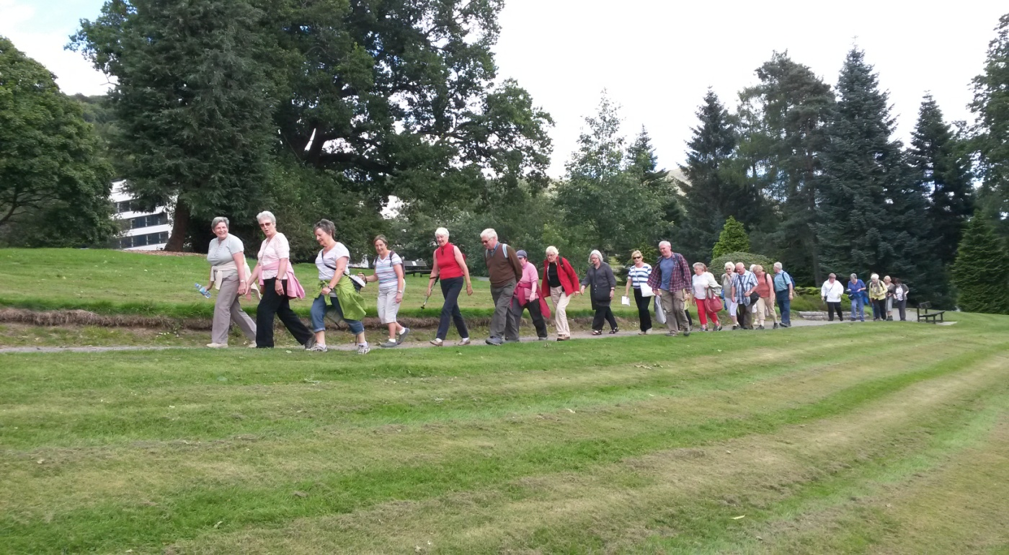
Along with our weekly walks we planned and provided 8 “nature walks” around the Forth Valley area with free transport for all of our walkers. We added a 45 minute (2miles) walk option to as many monthly walks as we could, to include those who could not complete the 3+ mile walk option. This enabled us to successfully reach a high of 55 walkers on our Monthly walk to Airthrey Castle.
Monthly walk to Airthrey Castle, August 2015
Participants tell us that our specialised monthly walks increase the opportunity for individuals to get out walking, be sociable, and visit areas within their locality that they may not have the confidence to visit on their own. (Please refer to Appendix 1).
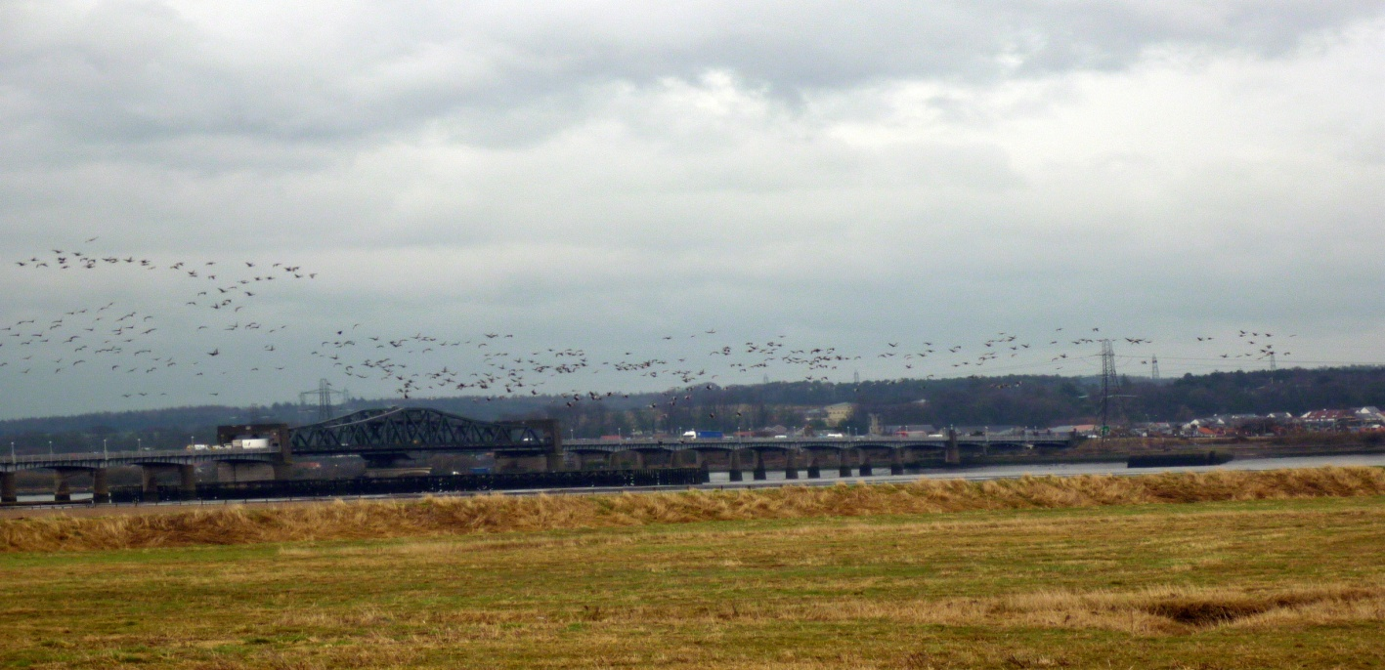
Furthermore, we partnered with up Inner Forth Landscape Initiative (IFLI) to provide 3 additional Monthly walks throughout 2015. These walks were designed to target those walkers unable to complete our normal monthly walks and for individuals who would like to venture to the Inner Forth area. On average, we welcomed around 18 walkers to each of these walks around different areas of key natural heritage interest. These opportunities enabled individuals to access new walking routes, be in a social setting and visit new areas of heritage and wildlife.
IFLI Walk to Bothkennar, March 2015
To boost our walking profile and resources, brand new walk card booklets were developed with the help of additional project funding from the Scottish National Heritage. These were developed to inform our walkers of all of our weekly walks we have on offer. Information about the area of each walk, map of each individual route, key information with regard to wildlife, key points of interest and facts about the area were included. This was designed to increase walking options for local people and have proven to be a popular and extremely effective resource.
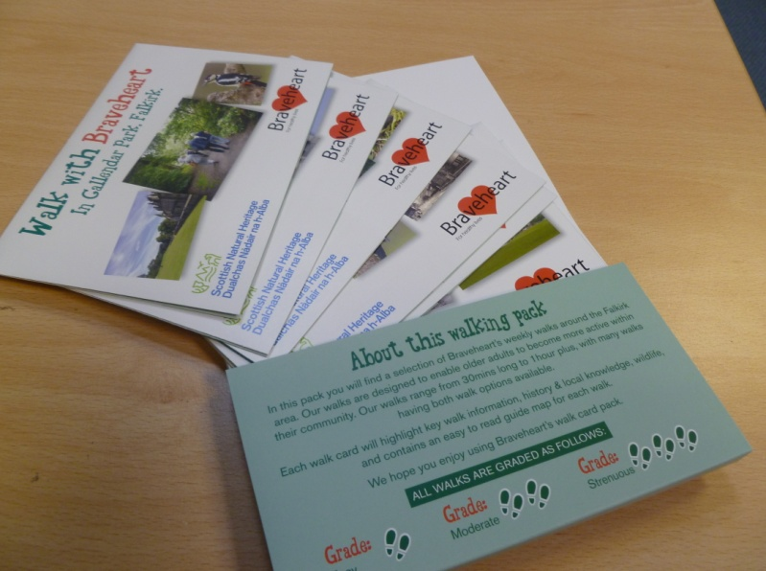
We also updated our walker database in August 2015 and developed a new Walk Information Booklet, giving new members key information regarding our walks.

Braveheart’s Walking Development Officer completed a Cascade Walk Leader trainer course and delivered a course in Clackmannanshire in April 2015. 12 new volunteers trained to came on board as leaders with our walking project. They thoroughly enjoyed the course and this training brought our total number of volunteer walk leaders to 26. This meant that we exceeded our original target for Walk with Braveheart in Year 1 by six. (Please refer to Appendix 2).
In early 2015, all Walk Leaders were provided with new clothing and equipment, which this makes them look very welcoming and visible on our weekly and monthly walks.
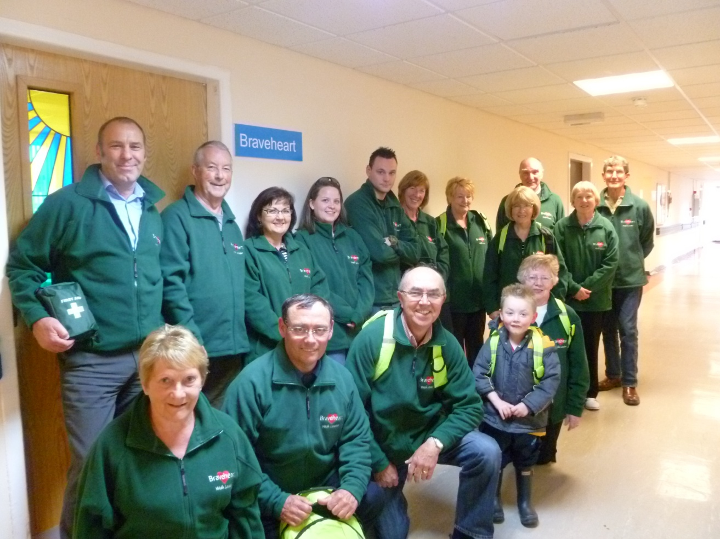
Some of our Walk Leaders modelling their new kit!

During this time a new walk was also developed within Clackmannanshire, targeting an area of deprivation. Leaders from the April training then led this weekly walk which launched on Wednesdays, lasting 30 minutes, taking in different routes each week. The leaders and walkers thoroughly enjoyed getting out of the Hawkhill Community Centre and having the encouragement and opportunity to explore their neighbourhood walking routes.
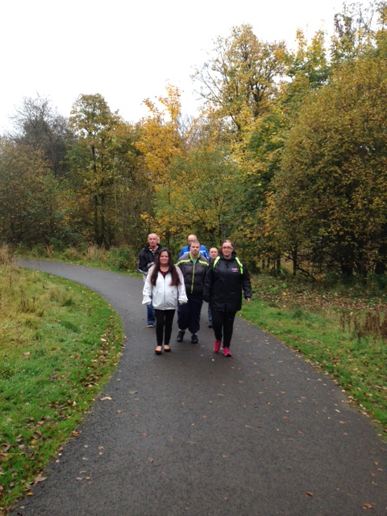

Hawkhill Walk, 2015

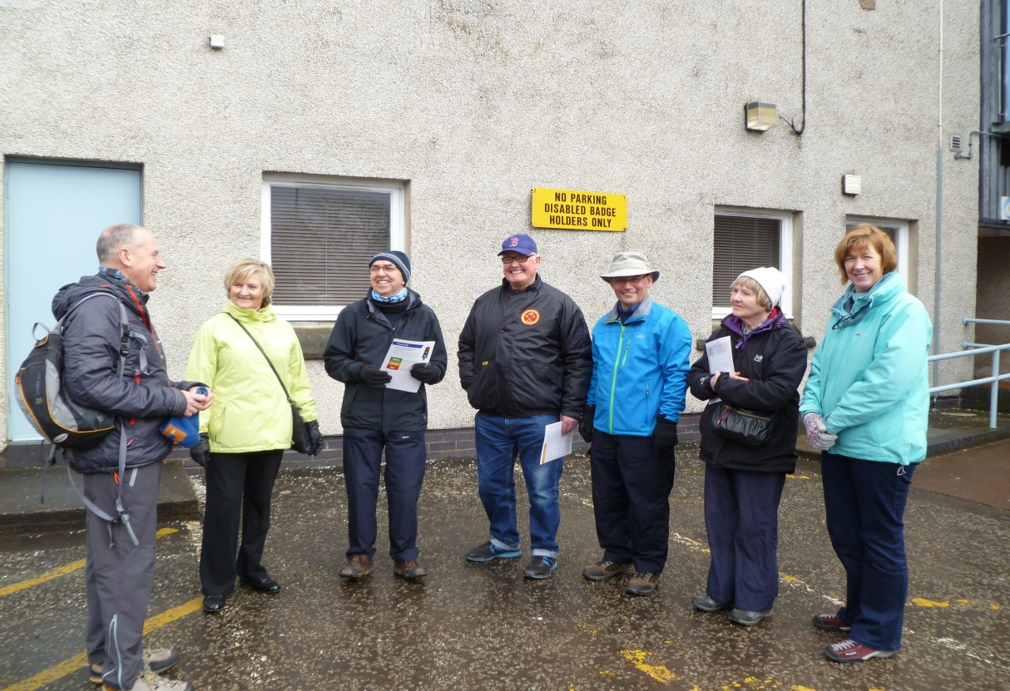
Ongoing training was provided for all our volunteer Walk Leaders throughout 2014 and 2015. Heart Start training courses were booked through Forth Valley College and Safety Outdoors and Strength & Balance training was provided by Paths for All. The Safety Outdoors training course was extremely beneficial for our leaders and gave them a new perspective on safety when leading our health walks.

Safety Outdoors Training, 2014

Braveheart was chosen by the TAG (The Advisory Group) as their charity of the year, to help provide more opportunities within the Forth Valley community. This group are a committee run by people with learning disabilities who discuss and develop new ways to get active and sociable within their community. We supported some service users on our weekly and monthly walks and helped them plan and run their very own Sponsored Walk. Braveheart was kindly presented with a cheque from the TAG group thanking us for supporting them throughout 2015.
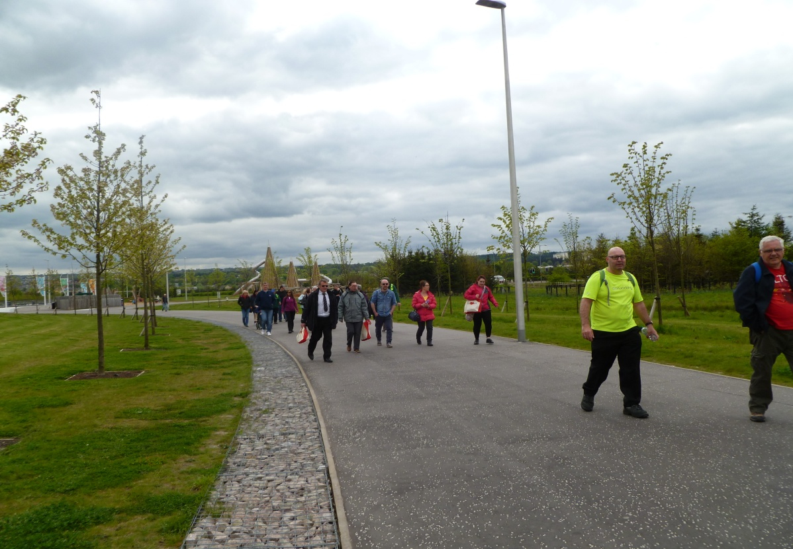

TAGS Sponsored Walk, 2015

The difference we made
- Increased opportunities for older people to get out walking (5,441 attendances on walks in 2014/15 and 411 walks led).
- Added a half hour walk option to 4 Weekly walks and a 45 minute option to many Monthly walks during 2015.
- Successfully promoted monthly walks, teaming up with IFLI and developing walk card booklets for the community.
- Developed new walks in Clackmannanshire.
- Improved the physical and social wellbeing of older adults within the Forth Valley area through walking.
- Trained new Volunteer Walk Leaders to help expand our walking programme.
- Improved and enhanced the profile of the Walk with Braveheart programme overall.

Targets

During this time period, walk leader training was essential to increase the support of our walkers and up skill any leaders who wanted to complete further training. With our bank of newly trained leaders, we were able to add shorter route options on four of our weekly routes and provide shorter 45 minute options on many of our monthly walks as well as developing a new walk in Clackmannanshire.
This enabled the project to increase opportunities for individuals of mixed ability to join our Braveheart walks. Increased numbers of participants enhanced their social and physical wellbeing and accessed new areas of interest within their locality.
From the success in year one, we developed new targets for year two. We specifically chose these to develop further the great foundation we had put in place. We chose to increase the volunteer training available to individuals in both Falkirk and Clackmannanshire to enable us to further increase opportunities to get out walking. We aimed to train new leaders in Clackmannanshire to develop and expand on the current work in this area. After the great success and feedback from our specialist monthly walks, we aimed to promote these walking opportunities to the wider public, and to continue our great partnership with Inner Forth Landscape Initiative.
(Please refer to Appendices 1 & 2).

Year 2
October 2015 - September 2016
Second year funding targets were the following:
- Recruit new Walk Leaders bringing our total trained to 35
- Develop 2 new Clackmannanshire Walks
- Train Clackmannanshire Walk Leaders
- Provide 10 Monthly walks
- Develop publicity for Monthly walks
- Deliver First Aid Training & Heart Start Training
What we achieved
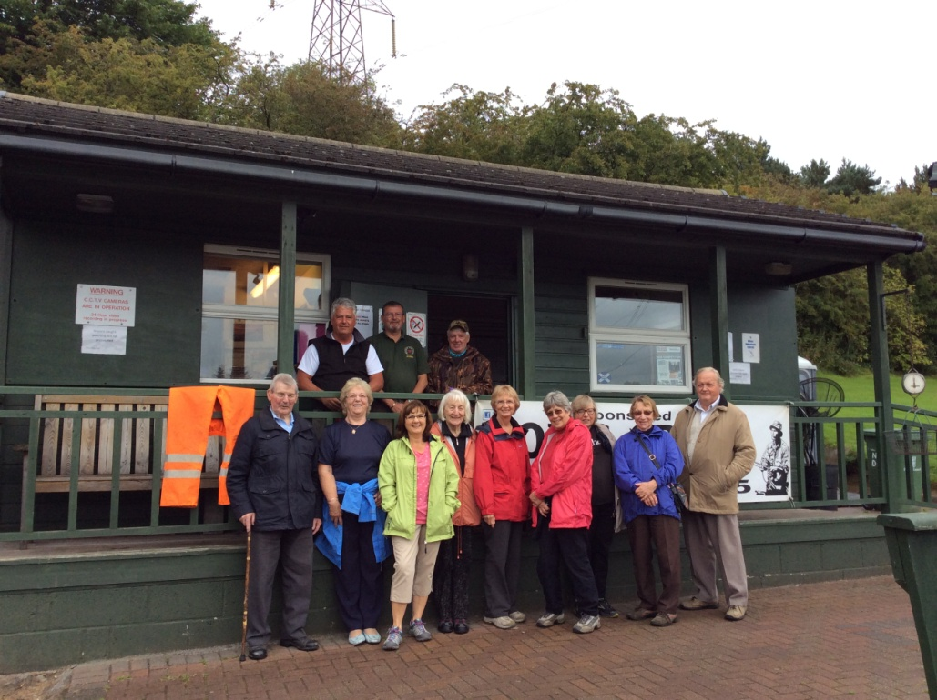
During this period, we increased the number of weekly walks around the Falkirk District from 13 to 15. We also added a new 30 minute walk option onto a weekly walk, now totalling 5 weekly walks with this additional walk option. In January 2016, we launched a brand new weekly walk in Polmont, with routes through the woodland and the reservoir. Numbers started low with around 3 walkers but then picked up to highs of 10 walkers.

Our Monday walkers at Polmont Fishery

This, therefore, significantly increased opportunities to get out walking and socialise within a new area of the Falkirk District community. During the year, we also enabled people less able to join many of our shorter, slower walks.

We introduced a second weekly walk in the Clackmannanshire area, following some feedback from individuals at the Hawkhill Community Centre. Some walkers found the 30 minute route a little too short, therefore we added a 1hour walk on Fridays each week to complement the 30 minute walk option on Wednesdays. This encouraged more people to walk twice a week, if they were able. This, therefore, brought our weekly walk total to 15 walks and we trained an additional 2 new walk leaders from Clackmannanshire.

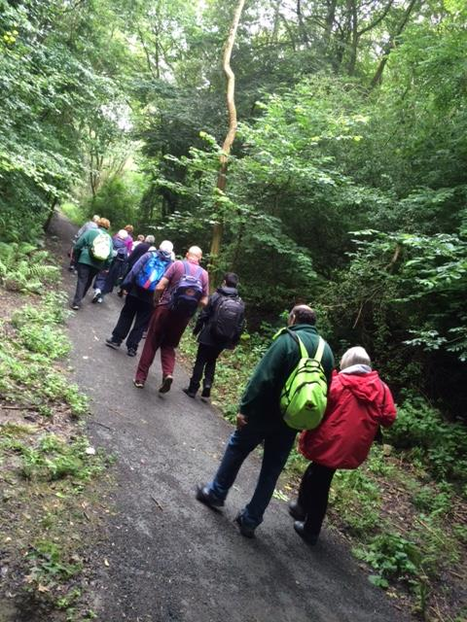
An increased number of 11 monthly nature walks around the Forth Valley area were achieved during this time, 1 more walk than our proposed target of 10. Fifty three walkers joined us for our Monthly walk to Bridge 49 in August 2016, with other walks reaching as high as 49 walkers. During this period we aimed to and successfully added a 45 minute walk option on to all of our monthly walks. This enabled many of our weekly walkers who can only complete a short walk to join us for these specialist walks. We developed our new monthly walk cards which were launched in January and highlighted our continuing partnership with The Robertson Trust, SNH and Inner Forth Landscape Initiative. These walk cards were promoted far and wide within the community to reach new groups and welcome new walkers outwith current walkers to join our specialist monthly walks.

Our short walk on our
monthly walk to Bridge 49

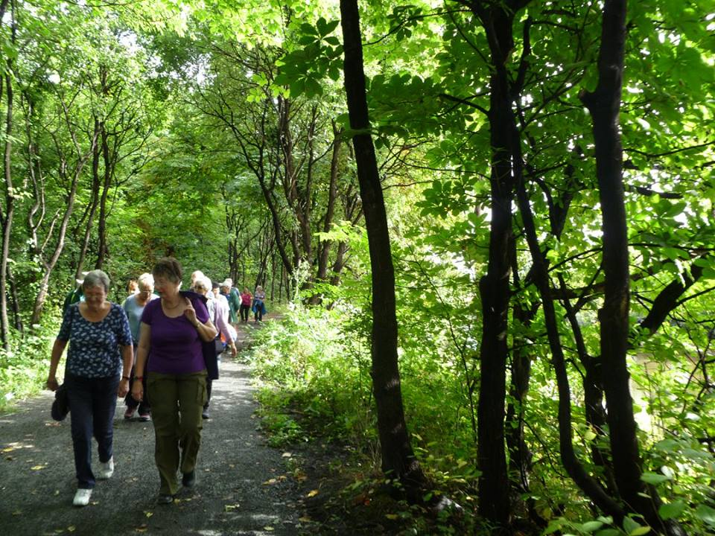
Again we continued and strengthened our partnership with Inner Forth Landscape Initiative by providing three additional monthly walks throughout 2016. These walks provided free transport for everyone to visit new sites of local history, heritage and wildlife within the Inner Forth area. These 45 minute walks proved increasingly popular in this second year of partnership, for example, we welcomed 22 walkers in September to Cambus Wetlands. Walkers admitted they would not feel confident, or know how to get to these places themselves. They reported thoroughly enjoying and feeling safe travelling with our groups, have made many friendships and increased their physical and social wellbeing. (Please refer to Appendix 3).
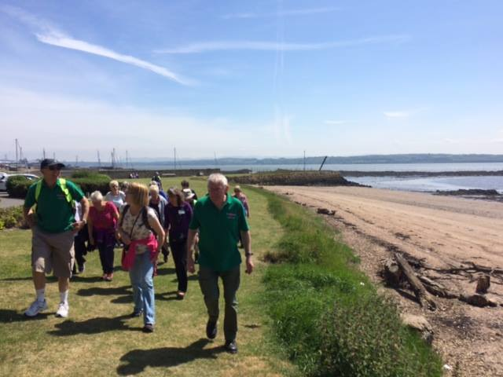
Limekilns, June 2016 Cambus, September 2016

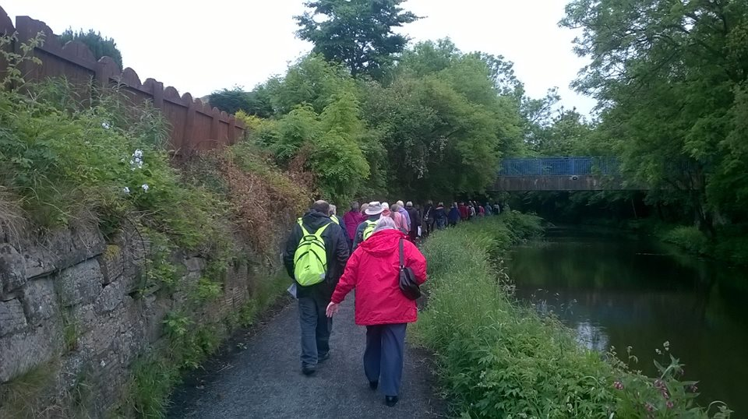
Further developing partnership links, Braveheart teamed up with Easyways Walking Holidays to hold our annual Big Fit Walk. This was a great success, with 72 walkers joining us on the day to explore Polmont village, learn about the history and heritage within the area and learn of new paths. This helped promote our new Polmont day walk which we launched a couple of months prior to this walk, increased individuals knowledge of Braveheart and promoted our message about getting out for a walk in their local area.
We also made new partnership links with Re-Union, Key Housing, Addictions Support & Counselling, Alzheimer’s Scotland, Forth Valley Sensory Centre & Paths for All.

All of the above was successfully achieved as Braveheart’s Walking Development Officer trained 16 new Walk Leaders during this time period, therefore bringing the total to 42. Volunteers play an important and significant part in the service we provide to our community. We, therefore, successfully exceeded our target of training a total of 35 leaders to this point in our funding grant. We also provided ongoing training such as Heart Start Training, Strength and Balance training opportunities and Safety Outdoors Training, bringing our total trained in this period to 14. (Please refer to Appendix 4).

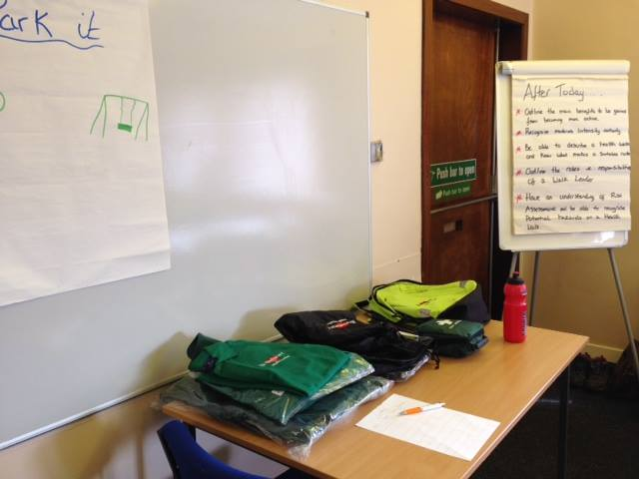

Walk Leader Course
April 2016

Through our new links with Forth Valley Sensory Centre, In February 2016 six walk leaders took part in RNIB training to support visually impaired, blind and deaf individuals on our walks. Our Leaders found this training highly beneficial and rewarding. We then organised a pilot walk for the newly trained leaders, with the plan for these walks to become part of our walking calendar.

In April 2016, Braveheart launched a quarterly newsletter to highlight the opportunities for local people, to publicise the great work achieved, and to inform people of plans for the forth coming months. We have found this is a fun and informative tool for us to reach out within the community.

We also carried out an intensive evaluation of the project using questionnaires and focus groups. We gained valuable and important feedback and thoughts from our volunteers and service users. This feedback allowed us to evaluate our programme in more detail and make clear plans for the future.

The difference we made
- Significantly increased opportunities and accessibility for older people to get out walking (6,024 attendances on walks between October 2015/16 with 476 walks led).
- Added a 30 minute walk option to 5 weekly walks and 45 minute option to all Monthly walks.
- Developed a second weekly walk in Clackmannanshire.
- Successfully continued and developed partnership working to drive our project forward.
- Continued to improve the physical and social wellbeing of older adults within the Forth Valley area through various walking opportunities.
- Trained new volunteer walk leaders to help expand and support our walking programme.
- Continued to improve and enhance the profile of the project overall through various different tools including our website, social media, newsletter and expanded mailing lists.
- During 2016 we evaluated our Walk with Braveheart programme, getting feedback from nearly 100 service users and welcoming volunteers and walkers to focus groups to gather specific feedback on our service. Our evaluation has generated excellent feedback. The full report can be found at www.braveheart.uk.net

Targets
During 2015/16 we successfully increased and promoted our shorter walk option, now offering this choice on 5 weekly walks and specifically on all of our monthly walks. We planned to continue to develop these options on our walks for 2016/17 and specifically look at developing our Inner Forth Landscape Initiative walks to make them more inclusive.
We successfully started another weekly walk in the Hawkhill area of Clackmannanshire, however, in late 2016 numbers decreased and it was a challenge to engage and motivate both leaders and walkers from this area to continue with their walking each week during the winter months. We therefore aim to make this a target going forward into 2017 to develop new walks to reach these groups and to get their feedback.
Having achieved steady walker numbers, our plan was to increase numbers moving our project forward to 2016/17. We planned to achieve this by continuing to strengthen our partnerships with Inner Forth Landscape Initiative, Forth Valley Sensory Centre and to further connect and engage with relevant groups.
After successfully receiving grant funding from Paths for All to make our walking project Dementia Friendly, we aimed to complete our training and develop 4 of our weekly walks to become Dementia Friendly. The objective was to specifically open our project up to new members who we can support across many walks.
We also aimed to publicise our new opportunities, partnership links and the groups we support through our website, social media, community group talks, and new publicity.
Please refer to Appendices 3 & 4 for both walk leader and walker quotes and case studies about their experience with Walk with Braveheart. For more in depth information, please visit our WWB Evaluation Report at www.braveheart.uk.net

Year 3
October 2016 - June 2017
The third year of funding targets were as follows:
- Train 8 new Walk Leaders
- Increase attendances by 10%
- Promote new walks
- Develop 4 Dementia Friendly Walks
- Plan and deliver 4 Sensory Centre walks
- Develop and continue Sensory Centre partnership
- Increase social interaction opportunities
- More publicity and partnership working
What we achieved
Our weekly and monthly walks have been doing extremely well during this funding year. With new walks developing this has enabled us to increase our led walks in relation to the previous year. So far this year, we have led 327 walks and we estimate that we will exceed 450 in this 12 month period. We have, therefore, welcomed 4,658 attendances across all walks in the previous 9 months. If attendances stay similar to what they have been this year we’re looking at reaching highs of 6,500 which is an 8% increase in the year, very close to our 10% target.
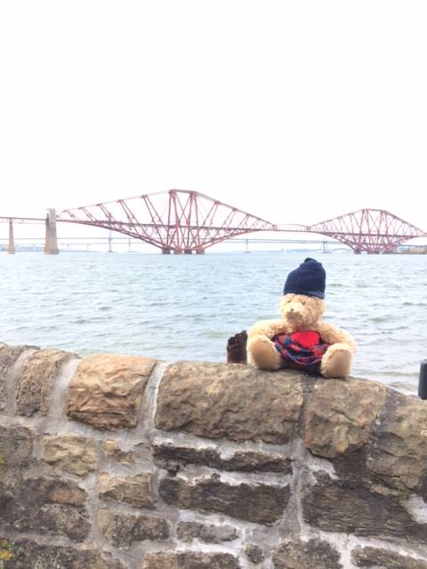
We also welcomed our new monthly walk mascot, “Wallace,” to our walks. He joins us for some snaps in the areas we visit. We furthermore developed a feature ‘walk of the month’ for our weekly walks. The features include a short description about when the walk started, information about the walk/ route and who we support. This was one of the new ways to help advertise the opportunities we have available to everyone and we found they were effective. Please refer to Appendix 5.

Wallace pictured on our South Queensferry Walk, May 2017.

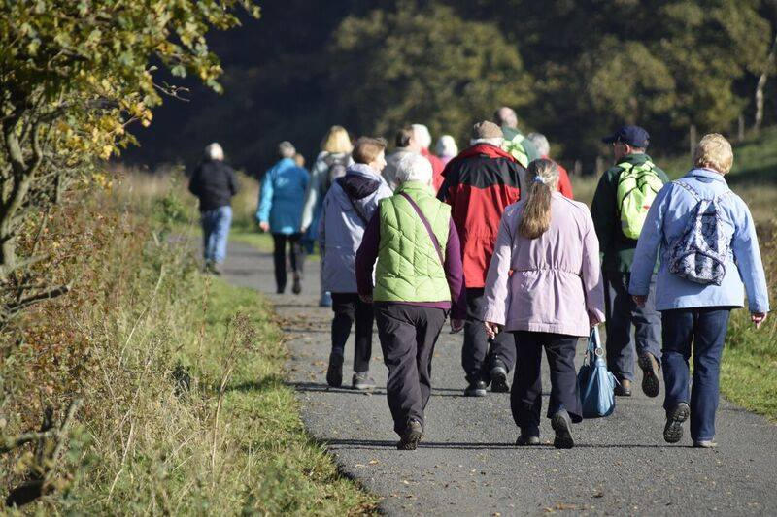
Due to this significant increase in walker attendances, we have added a 45 minute walk option to two of our busier weekly walks to accompany our 30 minute and 1 hour walk options already available to our walkers. This has enabled us to give more specific support and allow walkers to walk more at a pace that suits them. Furthermore, we again are making sure we have both walk options available on all of our monthly walks throughout 2017 and moving forward. We welcomed 50 walkers on our Monthly walk to Haggs in October 2016.
Monthly walk to Haggs, October 2016
Braveheart’s 2017 Sponsored Walk in June (now named ‘Friends of Braveheart’ walk) helped raise over £300 to support our project. This money helps to support training and transport costs to enable us to continue and develop the great work we do.
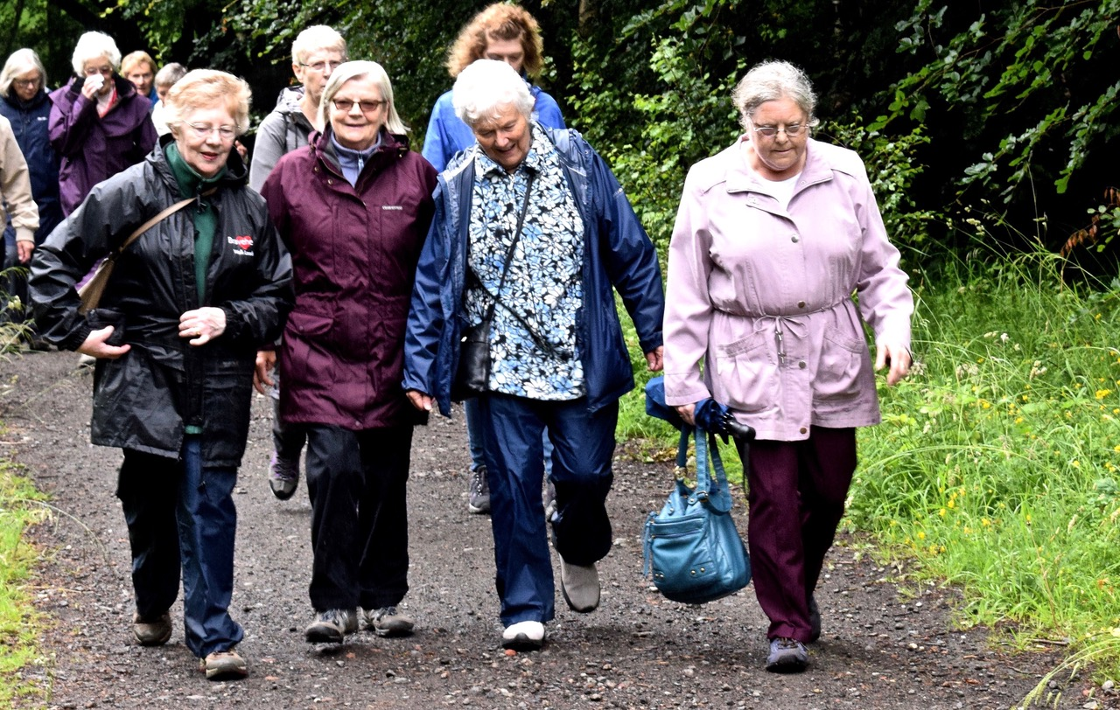
Too busy chatting to smile for the camera, Friends of Braveheart Walk, 2017

The Walking Development Officer trained another 4 volunteer leaders during this time and we currently have 8 on a waiting list as they were unfortunately unable to make the previous training dates at last minute. New leaders coming on board are increasing support to our project and enabling us to enhance the work we are doing, explained below. Further training for our leaders during this time included Strength & Balance training. Following this training, we delivered free taster sessions to individuals within the community.

In 2017, we also developed a targeted evaluation with our walk leaders. The evaluation focused on the support and development we offer through our project. Following feedback many of these points will be auctioned in the Autumn of 2017 to help further support and develop our walking project. Please refer to Appendix 6.

We have also re thought our walk support ideas for the areas of deprivation in Clackmannanshire. With weekly walk numbers being very low for both walkers and walk leaders in the last year, we decided to run a pilot of monthly walks designed to appeal these hard to reach groups. We have therefore developed plans to have two ‘Family Walks’ during July and a further two ‘Day Trips’ in August. We hope these walks with generate interest in the community as they will now have the opportunity to visit new areas within the Forth Valley area which they may have never visited before. If successful, we plan to run these walks monthly from September onwards.

Walk with Braveheart have continued our partnership working with Inner Forth Landscape Initiative (IFLI) to provide a further 3 monthly walks throughout the year. In 2017, we further developed our walks by adding a longer walk option (3 miles +) to mirror our shorter walk which is normally around 2 miles and lasts approximately 45minutes. These walks will, therefore, now run the same as our normal monthly walks.

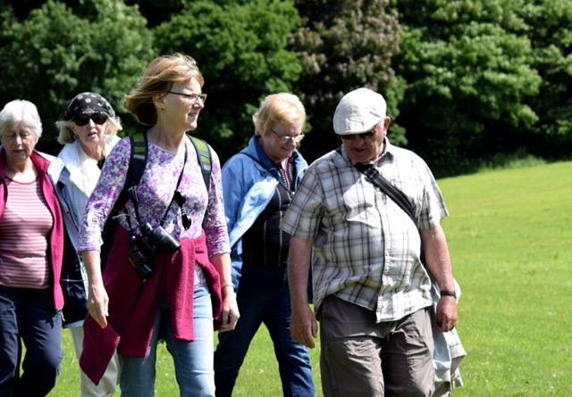
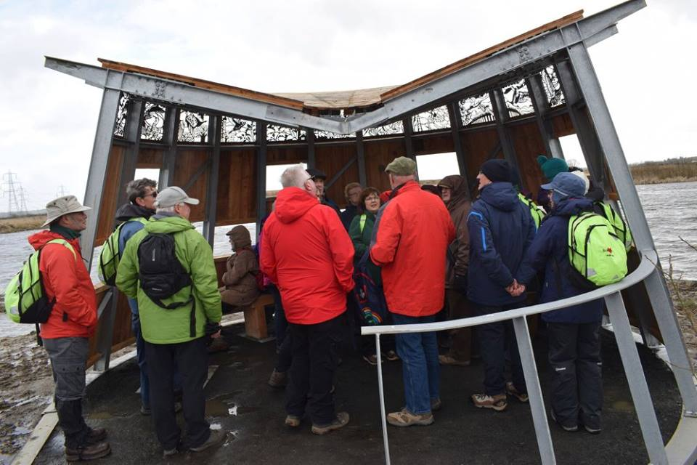
We welcomed 36 to the Black Devon Wetlands in March and 18 walkers to Kinniel Estate in June 2017. We appreciate the great support IFLI give us and our walkers thoroughly enjoy seeing and learning more about the Inner Forth area; we hope to continue and develop this work for as long as we can.
Black Devon Wetlands Kinniel Estate
In July 2017 there are plans for IFLI to provide a day long History & Wildlife Training for our Walk Leaders. This will enable them to feedback key interesting facts to our walkers about their local area and wildlife they may spot. This is a great way to further train leaders as many of our volunteers have a keen interest in history and/or wildlife.
After receiving a small grant from Paths for All Dementia Friendly Fund back in summer 2015, we started a one year plan to develop dementia friendly (DF) walks. Along with training our walk leaders, this also allows us to gain the knowledge and understanding with regards to understanding dementia, risk assessing DF routes, using various cue cards to support any walkers and also buy equipment our leaders may need.
We are proud to say we currently have 11 DF walk leaders trained, 5 of our weekly walks are dementia friendly and we support 3 individuals with dementia at present. We, therefore, reached our target of making 4 walks dementia friendly and hope to further promote the support we give to welcome new individuals to our project.

We had a project celebration day on our Bonnybridge walk, where we support two men with dementia, and also received our project accreditation. This was a lovely day where we all came together to celebrate the invaluable work we are doing and furthermore help promote the support we give. Please refer to Appendices 7 & 8.
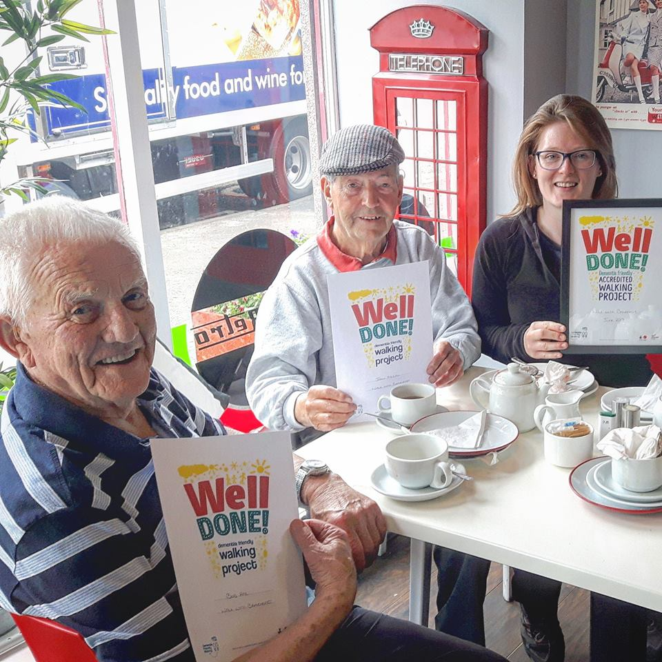

Our celebration & accreditation day

Following a community talk to an Epilepsy Connections group, co-ordinators of this group kindly offered free Epilepsy Awareness Training which 6 Walk Leaders attended in January 2017. Service users of this group found that they are too anxious to get out and about among their community due to their condition, but would like to become more active. We can now give these individuals extra support to get out walking in their neighbourhood by welcoming them to a few of our weekly walks, and any of our monthly walks if they wish. We again plan to promote far and wide the additional support we give to enable us to welcome new service users to our variety of walks.
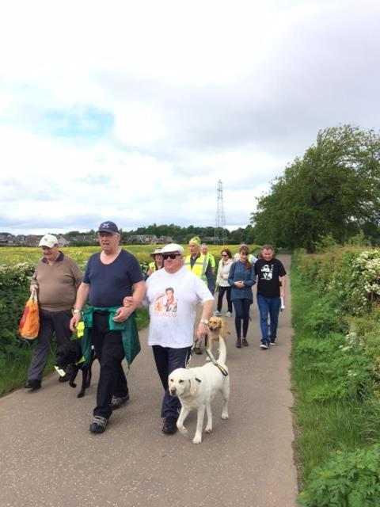
Braveheart has continued to develop our partnership links with Forth Valley Sensory Centre after training 8 leaders in RNIB (Supporting Blind and Partially Sighted People). Our pilot walk gave us great feedback, and we then put a timetable in place to continue these walks. These planned walks, now named ‘Friends of Forth Valley Walks’, are running from May - October 2017 with the hope that they will continue after this time. This means that we will have delivered 2 more walks than our original target. Our first walk in May, leaving from the Sensory Centre was well attended with 7 walkers and 6 sight guides and leaders. We also made new links and developed partnership working with another appropriate group to this project - Forth Valley Disability Sport.

Friends of Forth Valley walkers in May 2017

This partnership significantly increases the opportunity for people with a disability to get out walking and explore their community. Many people who require this extra support have been unable to access these opportunities. Our 2017 timetable will enable individuals to get a feel for the walks, which take in routes of the different areas of our normal weekly walks. This will then, hopefully, encourage and make people feel confident to join our weekly walks.

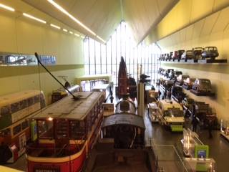
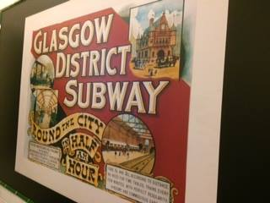
After some planning and reviewing, Braveheart organised our first Social Enterprise trip to Glasgow Transport Museum in April 2017. These trips are designed to increase opportunities for social interaction. This trip welcomed 44 service users for a day of socialising, walking and a learning experience going back in time to the industrial times of Glasgow. Everyone thoroughly enjoyed the day and look forward to our next trip to Edinburgh Botanic Gardens in July. These trips aim to have a key influence on physical and social wellbeing; giving anyone the opportunity to visit places of interest, meet new friends and socialise throughout the day.
Social Enterprise Trip to Glasgow

Further community links have also been developed with organisations such as Penumbra, Falkirk College, Falkirk Community Hub, Torwood Garden Centre, Glen Ochil Prison, and Caledonian Curling Club where we have developed new walking opportunities to get people more active or try something new. We also continued to provide community talks where we were welcomed by Larbert Women’s Group and Denny Wasp in 2016/2017. These talks are a great walk to inform people about Braveheart services, encourage new walkers and volunteers and answer any questions people may have.

The difference we made
- Further increased walker attendances and led walks (+8%)
- Further increased support to our walkers by having 45 minute walk options added to busier walks, 3 mile + walk added to our IFLI partnership walks, and all monthly walks with shorter 45 minute walk option
- Providing further training opportunities
- Re developed our Hawkhill Community Centre partnership by planning new monthly walks
- Making 5 of our walks dementia friendly and becoming an accredited walking group
- Providing Epilepsy Awareness training to support people on our walks
- Developing 6 RNIB specific walks and strengthening our partnership with Forth Valley Sensory Centre and Forth Valley Disability Sport
- Ran our first Social Enterprise Trip
- Make new, key partnerships throughout the community

Moving forward
We strongly feel that our project is now becoming more established throughout Forth Valley. However, there is still significant scope for this to develop further and support a wider range of individuals to become more physically and socially active throughout their community. The targets outlined below would be our main aim throughout 2018 and into the future:
- Increase walker numbers by promoting the options to the wider community as much as we can; including details of all the specific support we give.
- Continue to train leaders in all our support fields and welcome new people to support.
- Significantly Increase links with the NHS and specifically GP’s.
- We plan on signing some walk leaders up to do Council Mini Bus training to allow us to save on our transport budget and perhaps provide more monthly walks throughout the year.
- Further promote and enhance community knowledge of our dementia friendly walks.
- Continue key links with the Hawkhill community, targeting areas of deprivation, and providing a timetable of monthly walks.
- Continue partnership working with Inner Forth Landscape Initiative and increase number of joint walks we provide at the end of 2017.
- Link with and promote to appropriate groups to develop our RNIB specific walks.
- Develop walks within local care home.

Conclusion
The project has significantly developed over the funding period through having a Development Officer in post. All the achievements outlined in this evaluation report are due to the continuation of this post which has been possible through the match funding the Robertson Trust has been able to provide.
The funding has enabled continuity of support to the volunteers and has resulted in the service developing to meet local demand. The project now supports a much wider range of individuals including people with sensory impairment. The walks have also been amended to include options for less active individuals to take part which now offers a practical and supportive way for keeping people well for longer.
The evaluation appendices demonstrate in great detail the benefits of the walking programme in the words of the service users and volunteers. It is evident from their comments that the project is key to supporting people to become more physically and socially active.
Braveheart is seeking a further two years continuation funding from The Robertson Trust which would support us to continue to employ the Development Worker and further develop the service. We respectfully ask that The Robertson Trust will consider our request favourably to continue match funding the post.

Appendix 1
Walker Quotes
- “ I come for the social aspect”
- “I prefer to be outdoors, and being part of this group allows me to feel safe and make new friendships”
- “We feel fitter after the walks”
- “I thoroughly enjoyed the Grangemouth as that’s where I grew up”

What we asked our walkers
- How did you find out about Braveheart?
- What do you enjoy about the walks?
- How do the walks benefit you?
- Would you recommend the walks to family and friends?
What they said
- “Jim saw the advert in the Falkirk Herald, went along, really enjoyed it and persuaded me to try it. We’ve been going ever since”
- “We enjoy the company as much as the fresh air and exercise. With you’re walking as a group, bad weather isn’t an issue”
- Both Jim and Anne were fairly fit before joining Braveheart walks but they have also increased walking on their own

- Eileen picked up a leaflet in her local library
- “I love the company on the walks as I’m wary of walking alone”
- “I definitely feel fitter having joined Braveheart walking groups”
- “Yes, I tell everyone how great Braveheart walks are”

Appendix 2
“I’ve been a Walk Leader with Braveheart since 2006 and find it very fulfilling. Braveheart helps people adopt healthier lifestyles and it encourages social interaction. I’ve seen many new walkers integrate into the groups and make new friends as well as improving both their mental and physical health through it” Walk Leader Ian.
Walk Leader Martin Stewart
Trained 2015
After Martin retired following many years in the Navy he trained to take the lead on our weekly Linlithgow Loch Walk. After a few weeks of walking, he cut down on biscuits and snacks. Martin has now lost 4kg in weight and is feeling great. His doctor states the only thing he will die of is old age!
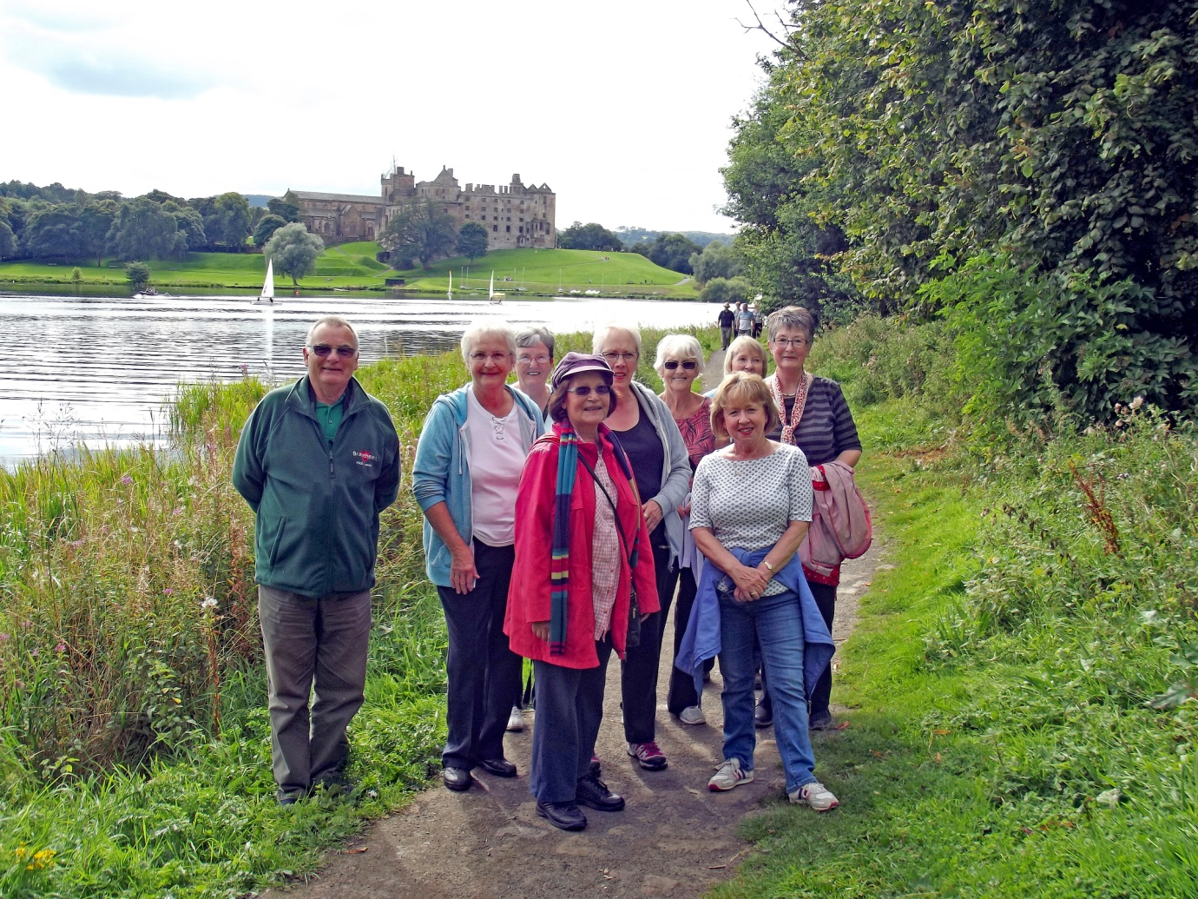

Walk Leader Charlie Colliar
Trained 2006
Having retired from the Fire Service after 33 years I felt I was now in a position and had the time to take on new opportunities. Up to this time I had not heard of Braveheart but I found out about it through an article in the Falkirk Herald in 2007 where they were looking for new walk leaders. Having always enjoyed walking I contacted the then Walking Co-ordinator.

After she had explained the role of a walk leader I felt I possessed the necessary skills to become a walk leader and so I volunteered to attend the upcoming training day. Shortly after my initial training I helped set up the first evening walk in Middlefield Falkirk starting at the Falkirk Football stadium and going to the sea lock on the Forth and Clyde Canal(being an evening walk it only runs from March to October). This walk is still going although it now is called the Helix park walk and although the route has changed slightly from the early walk it now has the benefit of passing the iconic Kelpies which had 1 million visitors in their first year. As well as this walk I also help out on other Braveheart walks throughout the Falkirk District.

I found the initial training day very interesting and equipped me with the necessary skills to become a walk leader. The training included background to the Braveheart organisation, risk assessment, first aid and CPR. Over the years I have attended various other training courses including First aid training and CPR refresher training which is essential for walk leaders as well as outdoor safety training, all of which I have found interesting and useful in my role as a walk leader.

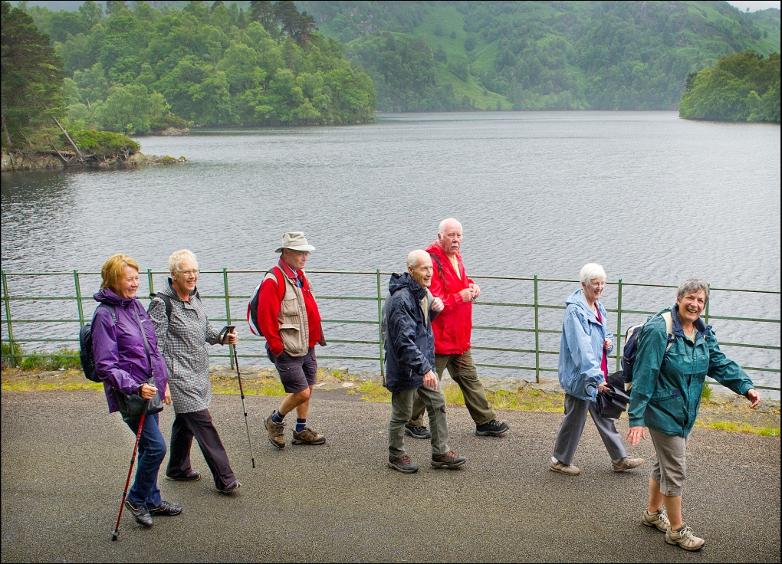
Having always enjoyed walking I find the Braveheart walks enjoyable. On the walks I have the opportunity to meet people from all walks of life many of whom have had health issues and are walking to maintain or improve their health. Additionally it gives many of the walkers a chance to meet other people and afford them the opportunity for social engagement, which for some is limited in their normal day to day life. During many of the walks the world has been put to rights and overall I have found that there has always been a lot of laughter.

As regards to myself I have got a lot of satisfaction from the walks over the years and as well benefiting from the walking for my own health I enjoy the outdoors and meeting people and would recommend it to people, who like me enjoy walking and meeting people.
Appendix 3
All taken from our 2014-2016 WWB Evaluation:
"Really enjoying the walks, the social part and the new friends I’ve made" Janette
"Good to meet new people and have a choice of walks" Irene
"The walks are popular and busy” Audrey
"The walks are wonderful. Especially the coffee with friends afterwards. Leaders front and back do a great job" Morag
"I think it is a very good thing and if I didn't have the walk I would probably not be out. I also have increased my social life through Braveheart" John
"I love walking with Braveheart, I’ve met some good people and have fun while walking" Paula, Walk Leader.
"I enjoy coming and all Walk Leaders are helpful and very chatty" Anne, unknown.
"A big thank you to all volunteer Walk Leaders" Iain
"I just hope Braveheart continues as I would really miss the friends I’ve made” Margaret
"Really relaxing and good socially" Frank, FVRH/ Stenhousemuir/ Monthly walks.
"The time and effort put in by Leaders is greatly appreciated. Each walk is not only fun but also beneficial health wise and on many occasions informative regarding the history of the areas visited" Una, FVRH/ Stenhousemuir/ Monthly walks.
"It’s helped me to get out to walk and make new friends" Carol
"I enjoy Braveheart walks very much, and the staff are very helpful" Tom
"It’s good for people who live alone. You mix with other people and everyone’s nice" Lily
"They are really good for you" Maurice, Walk Leader.
"It’s a great opportunity to get out and about" Lorna
"It’s great to meet new people, both walkers and Walk Leaders" Helen
“The social aspect is so important to combat loneliness- walking by yourself is not the same, and unless the weather is truly atrocious, it gives us fresh air and exercise on a regular basis" Moira, Dawson walk.
"Braveheart walks give people of all ages and fitness to mix together and a chance to improve their health. I think many of our walkers would really miss Braveheart if they did not have it in their lives" Jean, Walk Leader.
"I’ve loved the walks since retiring, it’s filled a void. It’s great setting out in the fresh air (even when raining!) enjoying the walking and the company. Thanks to the organisers and Walk Leaders, much appreciated" Alison
"I’ve discovered many local areas which I didn't know existed" Jessie, FVRH/ Stenhousemuir walks.
"It’ a good social event and it was a life saver when I was made redundant. I was able to get out the house to meet people" Janice
"I’ve enjoyed my time with Braveheart having meeting interesting and friendly people as well as helping me keep fit" Charles
"A great way to keep fit and interact with others while doing so" Jacqueline
"I have enjoyed all aspects of the walks, Leaders etc are very friendly and supportive" Agnes
"I hope that funding is made available for these to continue and offer more walks" Sandra
"If we have more leaders, means we can offer shorter walks as needed" Nahid
"I’ve seen the good these walks do. New walkers improving their fitness and going on to enjoy much longer walks. For many it's a chance to socialise and important we give this opportunity" Carol, Walk Leader.
"I feel safer in numbers and can go places I wouldn't venture on my own- thanks" Evelyn
"I’ve met so many nice people" Janette, Walk Leader.
"It’s friendly enjoyable and I'll continue until I 'kick the bucket'. My GP thinks it's a great thing" Bob
"Braveheart is a very welcoming organisation. The Walk Leaders are terrific and the company makes you feel safe which you often don’t feel walking alone" Margaret
"I enjoy the company and the Leaders are always obliging" Marge
"Leaders are well prepared, friendly and supportive" Ann, unknown.
"The leaders are well trained and take you to places of interest and scenery to enjoy" Jane
"It’s been great to see many friendships develop over the years until now it feels that we are now one big Braveheart family" Ian
"It gives people a purpose to get out of the house, especially those living alone” Pat
"I love it, I can't fault it" Eileen
"All my walks have been a positive experience" Maureen
"I really enjoy being a Leader and a walker and it’s something I would like to continue when I retire. I think this should be offered to all age groups- perhaps through a GP referral or recommendation from a health professional" Susan
"Volunteers and everyone at Braveheart provide a great service in helping to keep us all fit and active and the social aspect is great" Margaret
"Every experience I've had with Braveheart has been positive- there aren't any downsides at all!" Robert
"Good exercise and good company" Joan
"I enjoy my walks very much and if I want there are always other walks I can join in our area and I know I will be welcome. I always make them known to all my friends" Catherine
"Very rewarding" Isobel
"I enjoy the company while walking" Jean, unknown.
"I’ve enjoyed meeting people" Irene
"It’s thoroughly enjoyable and has a good social side" William, FVRH/ Monthly walks.
“The social aspect is so important to combat loneliness- walking by yourself is not the same, and unless the weather is truly atrocious, it gives us fresh air and exercise on a regular basis." Moira

Appendix 4
Robert Snedden
Trained 2015
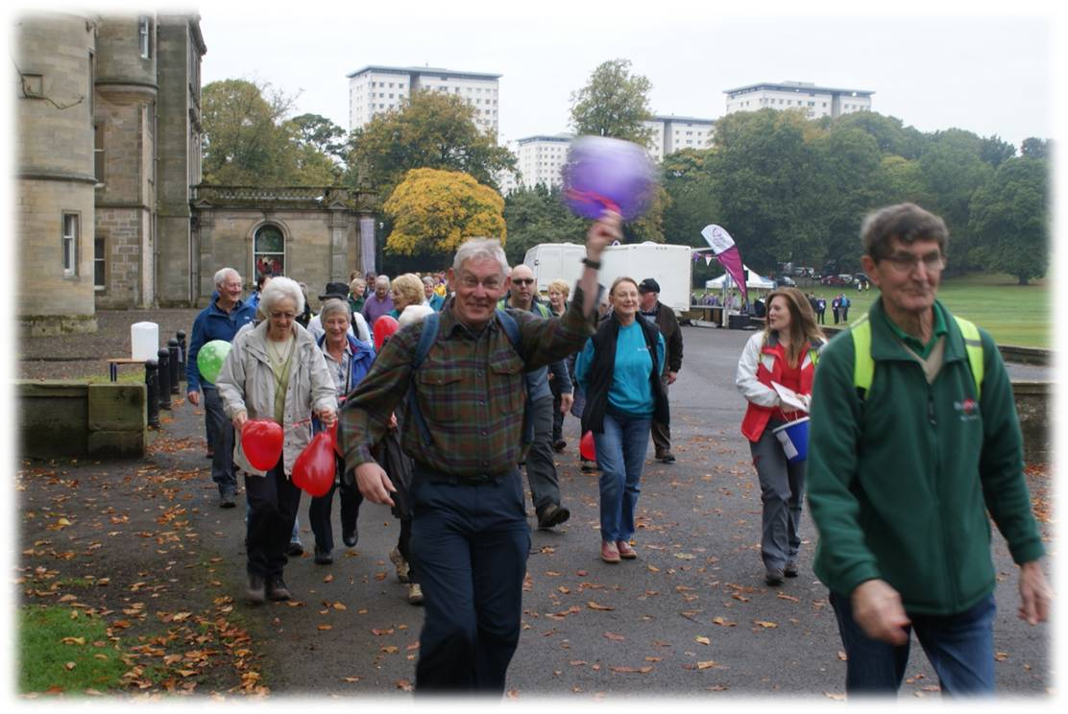

Robert is pictured with the purple balloon!

When asked if the walks have helped him both physically and mentally, Robert replies “oh good heavens, yes to both!” The walks take Robert out of himself as well as out of the house. He came to Braveheart at what was a very low point in his life and it was/is a lifesaver – “and I’d bet anything you’d find a lot of people who would say the same thing”.
“Don’t hesitate. It’s all good. You’ll find fresh air, fun and friendship and a great sense of belonging. On a Braveheart walk you could find yourself having conversations you might not have anywhere else - perhaps there’s something about the outdoors that makes people open up to each other! In my experience, there’s a lot of laughter on a Braveheart walk, but plenty of room to share more serious things too. If you’re a walk leader you’ll have the warm glow and inner contentment of doing something that’s entirely worthwhile and rewarding while at the same time keeping you on your toes mentally and physically” Robert.

David Smith
Trained 2016
David was associated with ASC, as a Peer-Supporter, helping with their addiction recovery service. He had previously mentioned to a colleague about doing a walking group and a couple of months down the line they attended one of Braveheart’s Walk Leader Courses.
The training was easy to get involved with and the training itself was enjoyable and flowed well ‘everything just seemed the fall in to place’ after that. David has also trained in Dementia Friendly walks since joining Braveheart and he feels that going out on the walks and meeting other leaders and walkers has helped him fit in well and learn along the way.
David has always enjoyed walking and used to go hill-climbing with a friend. Braveheart enables him to do something that he enjoys while meeting new people. Working alongside Braveheart has also given him the extra help to get through his HND course in Travel and Tourism at Falkirk College.
Since 2010 David has had ongoing problems with his back and his GP stated this will be the case for a long time and to get moving; ‘going out on the walks is giving me the exercise that I need to help build up my core strength and it helps with my problem’. The walks are also an effective way of getting out and meeting new people which stops you from being isolated sitting at home.
Advice from David: ‘anyone thinking of coming along on the walks should at least give them a try! If you don’t go then you will never know what you may think about them. They are a good way to get exercise and meet new people, and once you do it you will wonder why you never went before!
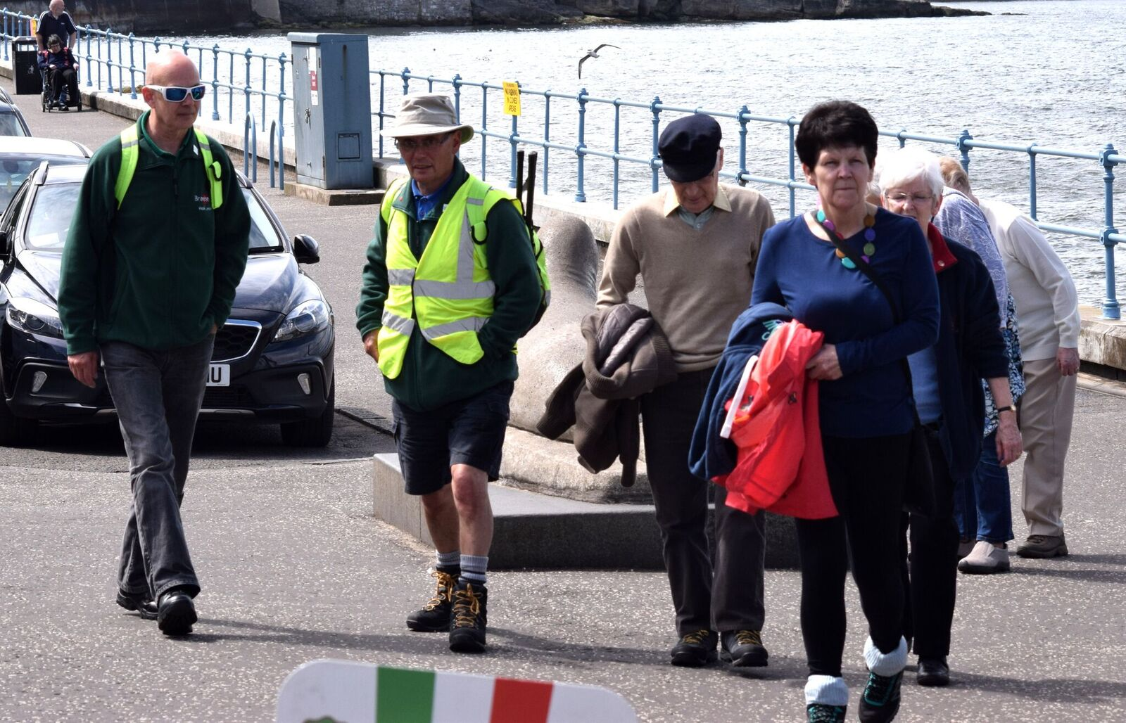
David is pictured far left in the below photograph

Walk Leader Quotes:
"It has been great to see many friendships develop over the years until now it feels that we are now one big Braveheart family." Ian, Walk Leader.
"Every experience I've had with Braveheart has been positive- there aren't any downsides at all!" Robert, Walk Leader.
“With volunteering with Braveheart for many years, I enjoy seeing the walks going from strength to strength.” Stanley Stewart, Walk Leader
"Braveheart walks give people of all ages and fitness to mix together and a chance to improve their health. I think many of our walkers would really miss Braveheart if they did not have it in their lives." Jean Glen, Walk Leader.

Appendix 5
Anne, Larbert Walker

Anne joined our Braveheart walks many years ago after her cousin introduced her to the walks. She was new to the area and wanted to meet new people. Anne enjoys walking and more so the socialising that comes with the groups; she is part of two weekly walks and often joins Braveheart’s monthly walks also.
Anne believes Braveheart walks have significantly helped her: “ I'm quite shy (hard to believe I know, but I have been forcing myself for years) and it's easier to find someone who will talk to me without having to be pushy”.
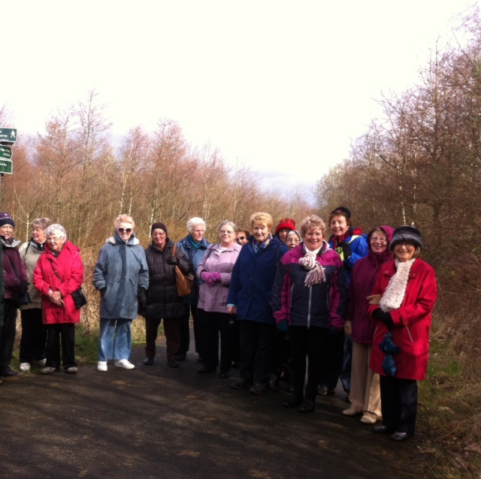
For anyone thinking of joining however isn’t sure, Anne gives this advice: “ I guess I would suggest they give it a try at least once to see if the walking is suitable for their physical condition and let them know it is a good way to meet new people”.

Anne is pictured forth from the left in this photograph

Janice, Bonnybridge Walker
Janice first heard about Braveheart from a friend who is the sister in law of one of Braveheart’s Walk Leaders. Janice was still working when she first heard about Braveheart and unfortunately the days/times/places of the walks didn't suit her work pattern.

Janice was then made redundant from work and was feeling isolated as her family and friends are not in the area where she lives. She felt she needed to get out and meet people in her local area. Janice remembered her friend mentioning Braveheart and she had also heard of the Ramblers. She checked both out on the internet but the Ramblers was not what she was looking for. As Braveheat had a walking group meeting up in Bonnybridge she decided to go along to see if it was for her.

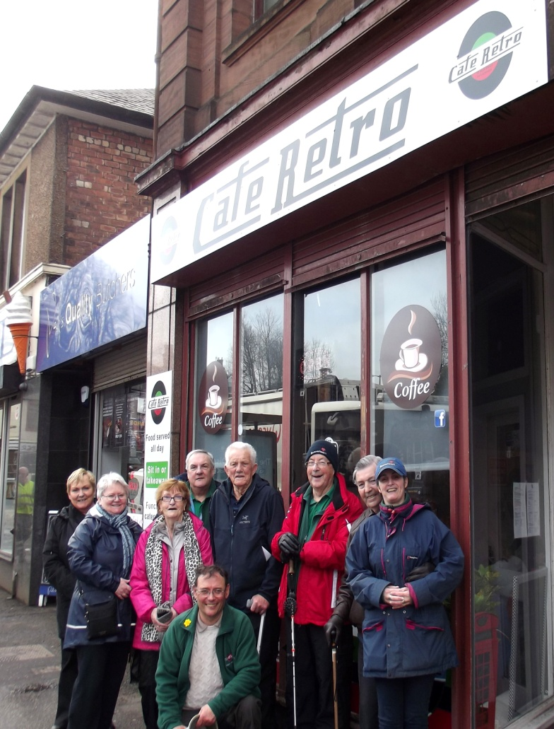
The things Janice most enjoys about the walk apart from the fitness aspect and getting out in the fresh air, is the companionship and getting to know new people. The whole social side of the Braveheart group is great and Janice’s confirms the walks have been of benefit both mentally and physically. After not working for a month or two and not being near family or friends. She was feeling lonely and isolated. She could feel herself slowly slipping into depression and felt if she didn't do something she would go into full blown depression. Janice was apprehensive going to the first walk but made herself do it and she hasn’t looked back. She feels fitter and has even lost a few pounds in weight and feel the benefit of that too.

“For people thinking of joining Braveheart or not sure, I would say to push yourself to try it. If it isn't for you, you don't need to go back but you owe it to yourself to try. I look forward to my weekly walks and have made a few good friends who I meet up out with the group for coffee or an away day every so often. The Braveheart group has other functions/events which you can attend if you wish - no pressure imposed. I think of Braveheart as an extended family. It can only do you good”

Janice is pictured second in from the left hand side of this photograph
Appendix 6
Walk Leader One to One’s 2017

- What do you get out of Volunteering with Braveheart?
Social side to it and fitness
- How do you find the support we give our walkers?
I find there is plenty of support for our walkers
- Is there anything further we can do to support our walkers/new walkers?
No none
- Moving forward, where do you see/hope WWB develops?

- What do you get out of Volunteering with Braveheart?
Social interaction, enjoy walking, great to see walkers develop and here interesting stories
- How do you find the support we give our walkers?
Fine- no complaints. Good support ‘as we see it’
- Is there anything further we can do to support our walkers/new walkers?
Make up new walkers packs to hand out to new walkers- simple flyers highlighting what Braveheart is & information about our walks.
- Moving forward, where do you see/hope WWB develops?
Keep supporting and developing DF & RNIB walks

- What do you get out of Volunteering with Braveheart?
Enjoy walking and the social aspect. Polmont walks are also local to my house
- How do you find the support we give our walkers?
Yes good. People can easily join and support is in place
- Is there anything further we can do to support our walkers/new walkers?
N/A
- Moving forward, where do you see/hope WWB develops?
Continue & develop DF & Epilepsy support. Once more leaders on board, we can open all walks up to everyone and give more support

- What do you get out of Volunteering with Braveheart?
I get alot out of it; enjoy recce’n walks, leading people and enjoy walking very much
- How do you find the support we give our walkers?
Excellent
- Is there anything further we can do to support our walkers/new walkers?
Don’t think so. Everyone supportive
- Moving forward, where do you see/hope WWB develops?
Develop a walk in Camelon- more walks once we have more leaders

- What do you get out of Volunteering with Braveheart
Fresh air, good company, exercise, getting out & about, worthwhile, improves physical and mental wellbeing
- How do you find the support we give our walkers?
Good. WLs keep people well and we have more than 1 leader on each walk
- Is there anything further we can do to support our walkers/new walkers?
Looking forward to IFLI training- be able to pass information on to walkers
- Moving forward, where do you see/hope WWB develops?
Make walks are inclusive as possible- train more leaders

- What do you get out of Volunteering with Braveheart?
Exercise, good company and satisfaction helping people
- How do you find the support we give our walkers?
Adequate
- Is there anything further we can do to support our walkers/new walkers?
N/A
- Moving forward, where do you see/hope WWB develops?
New walkers coming through Cardio Rehab!

- What do you get out of Volunteering with Braveheart?
Personal satisfaction, being in your community
- How do you find the support we give our walkers?
Very good- not just on the walks, weight management etc
- Is there anything further we can do to support our walkers/new walkers?
N/A
- Moving forward, where do you see/hope WWB develops?
Already well developed. Start new walks, welcome new leaders

- What do you get out of Volunteering with Braveheart?
I have got a lot of personal benefit from volunteering. When I first started I was recovering from a serious health problem which had impacted on my confidence and social skills. Volunteering built up my confidence and social skills. It is also voluntary work where you can see you are making a difference. Walkers enjoy the walks we take them and the social side of the walking is extremely important. I am very aware of the health benefits accruing from our work - very much “side of the angels” work. Working with other walk leaders is rewarding in itself. The support and good humour is always there and I have always felt fully included and part of the group
- How do you find the support we give our walkers?
On the day we are supportive of walkers and this can be seen in the move to three different grades of walk providing leaders available. We try to make a point of moving about to walk with different walkers, especially if they are on their own. Outside the walk I’m not clear what support, if any is wanted, should be given. I am aware some walk leaders have contact details of walkers and contact them if they don’t appear for couple of weeks to check they are ok
- Is there anything further we can do to support our walkers/new walkers?
Carrying on from Q4 I don’t know if there should be a more formal contact of walkers missing or whether this would be intrusive. If we have email addresses of walkers perhaps information could be sent to them online including other events which may be of interest to them
- Moving forward, where do you see/hope WWB develops?
I hope in the future that the groups work is fully recognised in relation to ill health prevention and that appropriate funding is forthcoming. We have and do always have on our walks a number of walkers with different health conditions. We have walkers with dementia, autism , mental health conditions along with assorted physical conditions. These walkers are simply included. It is good that training is now been given re conditions such as autism and epilepsy. Are we saying that we are now going to provide walks specifically for certain groups ? Are homes going to ask us to arrange walks for their dementia residents ? With regard to epilepsy are we fully insured when we advertise this. I am very aware working with clients with epilepsy how serious this can be. Chances are everything will be fine but clearly a risk. To advertise this means leaders qualified to give meds if needed and know how to follow medical protoc0ls - walks advertised as such would need to have back up leaders who can cover when others off. We can only expand the number of people with disabilities on walks if we have enough trained leaders to cope if this expands.
Another concern is the number of walk leaders. The Stenhousemuir walk is very short of leaders, as is the hospital. It just needs a few to be injured/unwell to cause problems. It can lead to cutting the choice of walks. In addition to this volunteers appear to be asked to do increasing activities other than walks. While many of us are willing to do this I have heard complaints of volunteers being taken for granted and asked to do too much. This is about the organisation not individuals

- What do you get out of volunteering with Braveheart?
Being part of group of friendly people with an interest in supporting others in developing healthier, happier life style
- How do you find the support we give to our walkers?
Over the time I have been a WL support to walkers has been extended to include the more vulnerable and less able in the community
- Is there anything further we can do to support our walkers/ new walkers?
Some sort of token/award e.g. Lapel pin to identify walkers. It could go through
bronze, silver, gold after completed number of walks or time period.
A postcard size feedback questionnaire they could complete and send in after a few
walks with their views and or suggestions
- Moving forward, where do you see/ hope WWB develops?
Would like to see greater number of people taking part, but know the difficulty of
trying to drum up interest. Promotion of Braveheart by health services to encourage more walkers

- What do you get out of volunteering with Braveheart?
Helping other people, improve personal fitness, meet new people
- How do you find the support we give to our walkers?
It is sufficient
- Is there anything further we can do to support our walkers/ new walkers?
No
- Moving forward, where do you see/ hope WWB develops?
I hope it does not get too big and expand too quickly

- What do you get out of volunteering with Braveheart?
Enjoyment, meeting new people and learning new things, amazing the amount of new things I’ve learned with just talking to the other walkers
- How do you find the support we give to our walkers?
I like to think we keep them up to date and well supported and looked after
- Is there anything further we can do to support our walkers/ new walkers?
We have a good core of regular walkers and all seem to be very happy and look forward to our walks, for all walkers if we haven’t done it we should maybe consider a short survey on things they would like to see when out walking and so on
- Moving forward, where do you see/ hope WWB develops?
Hopefully the success we have at the moment continues, I would like to see more promotion done by AHP’s and GP Surgeries/Health centres as it is now evidence based that walking without doubt is good for your health, it all began with Cariac Rehab all these years ago maybe time to revisit and reintroduce the walks as part of Cardiac Rehab again

- What do you get out of volunteering with Braveheart?
A sense of doing something worthwhile
- How do you find the support we give to our walkers?
Good
- Is there anything further we can do to support our walkers/ new walkers?
No, support is very good
- Moving forward, where do you see/ hope WWB develops?
An increase in numbers using Braveheart

- What do you get out of volunteering with Braveheart?
I get a lot of satisfaction at a job well done. The friendship between the folk and the leaders is great. The feedback is good too so I know I have taken the folk on a good walk
- How do you find the support we give to our walkers?
I think it is good. Sometimes I find that I haven't handed out the latest info but that is due to me losing the leaflets in my bag and not to the timing of the information from yourselves
- Is there anything further we can do to support our walkers/ new walkers?
I can't think of anything!
- Moving forward, where do you see/ hope WWB develops?
I can see the need for more walk leaders, as the current walkers being used to assistance, get older and slower. There is already a trend for a slower short walk in addition to the current short walk. It is difficult as the slowest person is the one who most needs our support. For short walks I think the minimum number of leaders should be two so that one can fall back with the 'slow coaches' and at the same time letting the fitter slow walker proceed at their pace. We risk putting short walkers off if we walk at the slowest pace

- What do you get out of volunteering with Braveheart?
I enjoy meeting new people and feeling part of something. Now that I have been going on quite a few different walks I am finding that I am enjoying it more each time I go along. It is also nice when people recognise you and welcome you with a smile and say hello when you walk up to the group. One of the main reasons to get involved was to get out and to enjoy walking which I have always done but somehow never seemed to have the time to do so. It helps to build fitness levels up as well
- How do you find the support we give to our walkers?
The support from the organisation and its staff is second to none, you know if you require anything that all you need to do is ask
- Is there anything further we can do to support our walkers/ new walkers?
The best way to help the Braveheart walkers is to keep them involved in what is happening, let them feel part of what is going on with the organisation. Asking them what they want and if there is anything that can be done to help them enjoy their experience
- Moving forward, where do you see/ hope WWB develops?
I would like to see Braveheart expanding if possible, the social enterprise venture would be a good thing if we can get more people involved. Like everything starting of it may take time but perseverance can prove profitable in the end. As most of the walkers have a bus pass it’s as if their saying to themselves “I can get there for free”. To get them to change that attitude we need to take them places that they would not normally be able to go to

- What do you get out of volunteering with Braveheart?
A little bit of exercise, socialising and also the feel good factor of walking with others who may not normally walk if alone
- How do you find the support we give to our walkers?
I think the support is very good and after all I don’t think they would attend the walks if they did not feel supported
- Is there anything further we can do to support our walkers/ new walkers?
To continue to make new walkers feel part of the walk by interacting with them and getting regular walkers to do the same
- Moving forward, where do you see/ hope WWB develops?
I hope it continues and grows as I think it is an excellent way of allowing people access to some exercise, fresh air and also the chance to meet new friends

- What do you get out of volunteering with Braveheart?
Hopefully making a difference to our walkers ability with the choice of walks provided. Meeting so many nice people on the walks. Doing something worthwhile with my time
- How do you find the support we give to our walkers?
Our walkers are very well supported given the choice of walks available
- Is there anything further we can do to support our walkers/ new walkers?
Can’t think of anything
- Moving forward, where do you see/ hope WWB develops?
For Braveheart to develop further more walk leaders are necessary

- What do you get out of volunteering with Braveheart?
Exercise, fresh air, company
- How do you find the support we give to our walkers?
Fantastic, information re support given to walkers is good
- Is there anything further we can do to support our walkers/ new walkers?
Better communication between WLs, specifically on the walks
- Moving forward, where do you see/ hope WWB develops?
Develop in Care Homes

- What do you get out of volunteering with Braveheart?
Meet nice people- met 100’s over my time with Braveheart. Doing something useful, routine, keeps you active during retirement
- How do you find the support we give to our walkers?
Maybe push to attractive more males to our walks
- Is there anything further we can do to support our walkers/ new walkers?
N/A
- Moving forward, where do you see/ hope WWB develops?
Keep going- get plenty of participants and volunteers

- What do you get out of volunteering with Braveheart?
Encouragement and meeting other people
- How do you find the support we give to our walkers?
Good- with the amount of people we have they all know what is going on and are well supported
- Is there anything further we can do to support our walkers/ new walkers?
N/A
- Moving forward, where do you see/ hope WWB develops?
Support what we have going on

Walk Leader Evaluation
Number of Walk Leaders who responded to questionnaire: 19
74% of Walk Leaders highlighted that they enjoy the social aspect of volunteering, 58% saying they feel like they are doing something useful and being helpful within their community, and furthermore 53% enjoy the exercise aspect of being a Leader.
All Leaders expressed that they feel the support we give our walkers is adequate- good- excellent. In relation to supporting new walkers, 58% of Leaders say they feel there is nothing else required or additional needed to how we support them at present. The remaining 42% made the following comments:
- New walker packs- containing information about Braveheart, walk cards, new walker form etc.
- Looking forward to IFLI training to then be able to pass information onto walkers
- Formal contact needed to follow up missing/ non returned walkers
- Awards for people attending walks- gold/silver/bronze
- Short survey to walkers asking what they’d like to see/ change on walks
- Continue to make new walkers feel welcome
- Better communication between Walk Leaders
Moving forward with Walk with Braveheart, we received valuable feedback from nearly all of our Leaders:
- Two Leaders highlighted to keep supporting DF and RNIB walks
- Six commented on training more leaders to support what we currently have and move forward
- Two mentioned about starting a news walks, specifically in Camelon
- Cardio Rehab links and referrals
- GP links and promotion of Braveheart through health services
- Continuing/ developing disability walks or integration
- Develop WWB in Care Homes
- Support what we currently do

Appendix 7
Rab, Bonnybridge Walker/ Carer
Rab heard about our Braveheart walks through his neighbour John, who has been attending our walks for over 10 years. Rab joined our walks in 2016 to support John, who is living with Dementia. Aside to supporting John, Rab wanted to come along to meet other people, enjoy something that interests him and furthermore improve his health.
Rab gets as much out of the walks as everyone else at Bonnybridge as he thoroughly enjoys talking to people, and specifically finding out from others what events are coming up/ happening in the area. He gets up in the morning and chaps John’s door ‘I’m just used to it now and look forward to coming’.
Since joining the walks last year, Rab has significantly improved his physical health as his GP said to him to keep walking. Being a recovering alcoholic and 27years alcohol free, Rab thoroughly enjoys getting out and about and feeling the benefit. ‘I’m still here anyway’ laughs Rab.
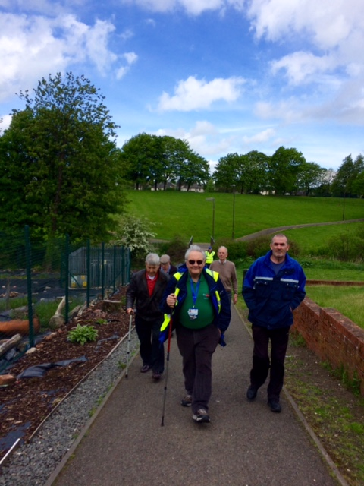
For anyone who is thinking about joining Rab states you should ‘come and try it out, the leaders are excellent!’

Rab is pictured far right in this photograph

John McColl, Bonnybridge walker

Following on from his retirement, John joined the walks in 2003 when Braveheart’s Bonnybridge walk started. He spotted an advert in the local Falkirk Herald about Braveheart’s new walk starting in his hometown. John didn’t know anyone before joining the walks however he had nothing to do and wanted to get out and about in his local area, and meet new people.
When John started on his first week he met Walk Leader Stanley Stewart and Walking Co-Ordinator Gail who warmly welcomed him to the walk; he has made many good friends over the last 13 years of walking with Braveheart and meets up with Walk Leader Maurice- who initially started as a walker then trained in 2008- on a week to week basis for a cup of tea and a catch up.
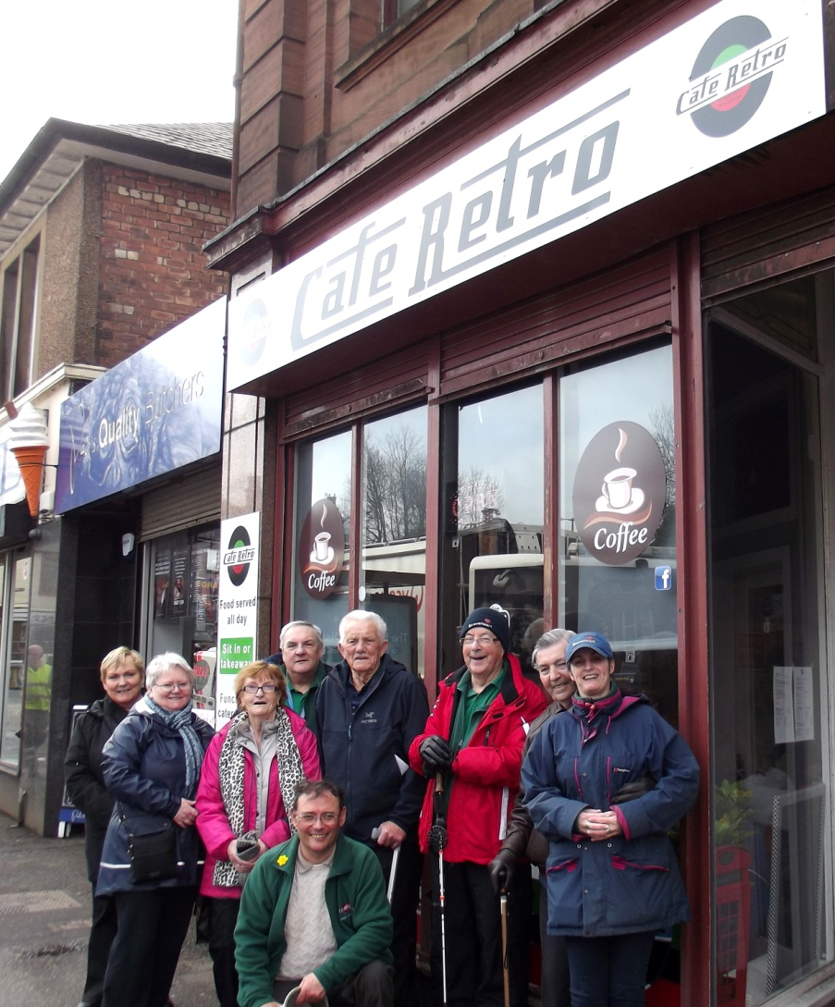
John was diagnosed with Dementia back in 2014 and he finds the walks extremely beneficial as it helps him keep a routine and continuously meet new people. John thoroughly enjoys the company and keeping active; he also states it’s easy for him to talk openly to his friends on the Braveheart walk, than to a group he doesn’t know. John strongly highlights that ‘Braveheart is keeping us alive’.

Dementia Friendly Walker Keith Scott- Forth Valley Royal Hospital Walk
Spoken by Carer/ Wife Alice Scott

After explaining to Alice Scott about our new Dementia Friendly walks and the new support we are giving, she was delighted with this and very pleased to see the Walk with Braveheart project moving forward and supporting more individuals, specifically her Husband Keith who is living with stage 2 dementia.
Keith (60+) has always been a keen walker all his life and our Braveheart walks enable him to keep this up through his day to day life:
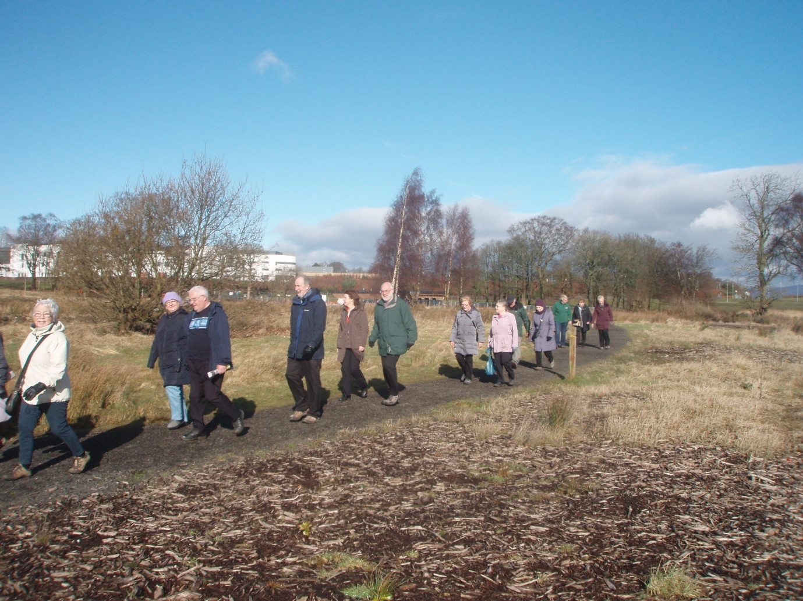
‘This group allows me to keep Keith in a routine and allows him to continue his walking, which was a great passion of his. I hope to bring him for as long as he’s able to’ Carer/ wife Alice, FVRH walk.
Keith pictured forth in from the left of the below photograph

Appendix 8
The Braveheart Association Launches Dementia Friendly Walks
Paths for All News Article
Walk with Braveheart has launched its Dementia Friendly Walking programme and received their Dementia Friendly Walking accreditation certificate. Volunteers and walkers gathered in Bonnybridge to mark the occasion with a walk and celebratory lunch.

Over the past year, The Braveheart Association has been working towards their Dementia Friendly Walking accreditation, putting in place a range of support to make their walks more accessible to people living with dementia. This has included Dementia Friendly Walk Leader training for volunteers and staff, choosing walking routes that are well lit, quiet and interesting walking routes and building local partnerships with dementia organisations.

Walk with Braveheart now offer five dementia friendly walks in Forth Valley.

Walk with Braveheart Development Officer Eva Finlayson said, "our dementia friendly celebration had a great turn out from all. Everyone attended to show their support of our dementia friendly walking groups. We enjoyed some chit chat along the way and of course some lovely refreshments at Café Retro after our walk.”

Paths for All and Walk with Braveheart also recognised the achievements of John and Bob, two walkers who have a dementia diagnosis. They were nominated by Eva as Stars of the Dementia Friendly Walking project.

John is a founder member of the Bonnybridge walk. He joined primarily to meet new friends and has been a regular ever since. John maintains that the walks “keep him going.”

Bob has been attending the walks for seven years and was introduced to them by John. He prefers the longer walking group and at 91 is still going strong.

John and Bob thoroughly enjoyed the day, as they do each week, and truly appreciate what we are doing. They both thanked Paths for All for their Dementia Friendly Stars badge and certificate.

Kayleigh Sinclair, Paths for All Development Officer, said, “we are delighted to present the Dementia Friendly Walking accreditation to Walk with Braveheart and acknowledge the amazing contribution of John and Bob. Eva and her volunteers have worked incredibly hard over the past year to achieve the accreditation.”

Paths for All are developing Dementia Friendly Health Walks across Scotland to support people living with dementia to benefit from the physical, social and mental benefits of walking in supportive environment. This work has been funded by the Life Changes Trust.

Braveheart offer five dementia friendly walks leaving from Polmont Woods, Forth Valley Royal Hospital, Polmont Canal, Bonnybridge and Stenhousemuir. For more information, contact Eva Finlayson eva.finlayson@nhs.net.

