Braveheart is looking for Volunteer Walk Leaders!!
FREE Course Details Below
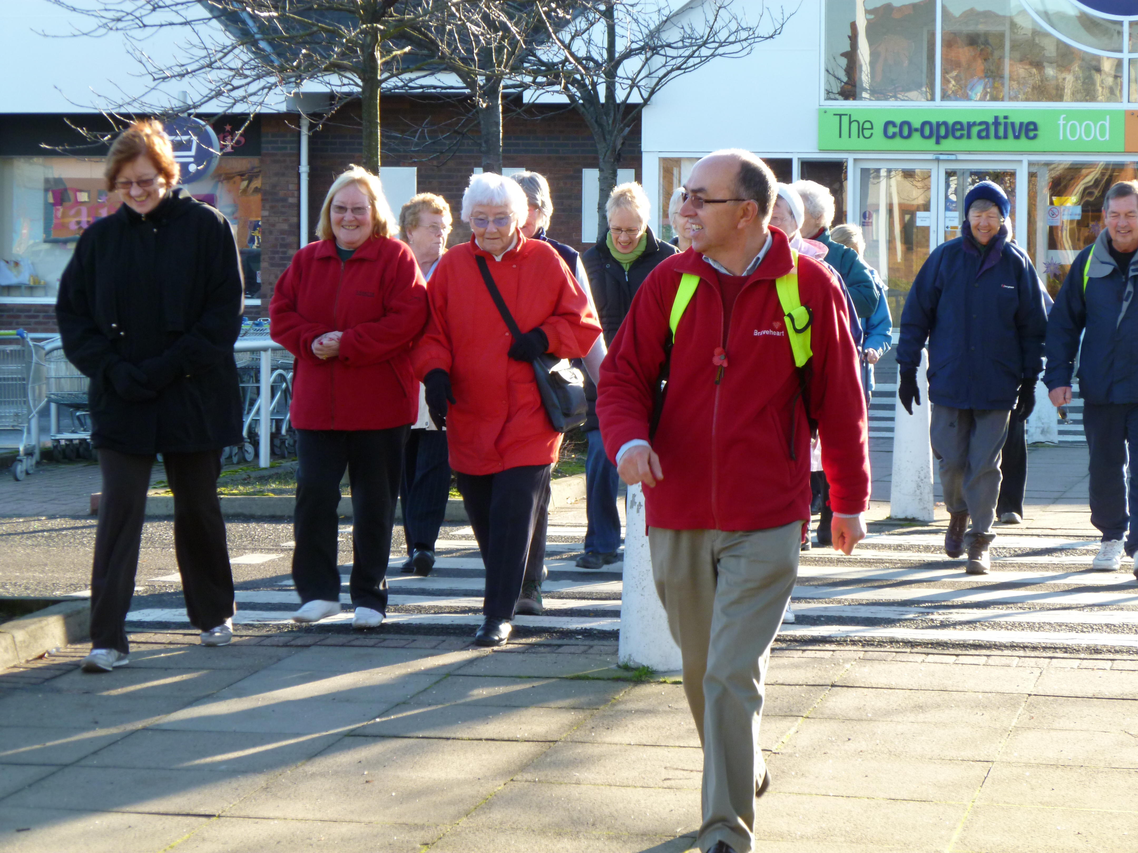

Braveheart is looking to expand their walking project in both Falkirk and Clackmannanshire…

We are looking for Volunteer Walk Leaders interested in supporting adults to become more active through walking, within local paths and green space. An interest in the outdoors in beneficial however no previous experience is required as full training is given.

Our Weekly and Monthly walks are for individuals of all abilities where everyone can enjoy their surroundings in a friendly and safe environment.

Course Details

We are running a FREE Walk Leader course for anyone who is interested:

Wednesday 29th April
10am-4pm
Hawkhill Centre, Alloa

To book a place on this course, or If you have any questions please call 01324 673703. We would love to hear from you.

