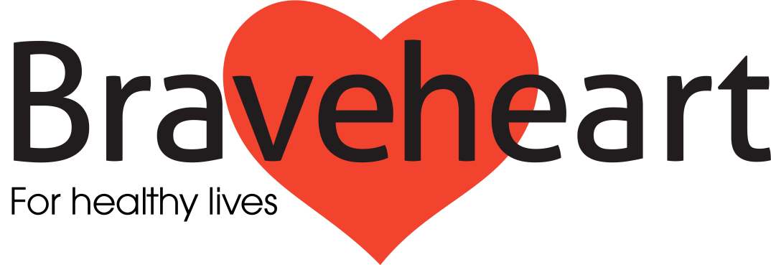

Your Introduction to Volunteering

Produced by The Braveheart Association - 2015

The Braveheart Association

The Braveheart vision is that every adult in Scotland with or at risk of a long term condition, has access to a programme of health improvement such as that developed by Braveheart.

Braveheart is a registered charitable organisation in Scotland with its head office in Falkirk Community Hospital, working within Forth Valley. We support people with or at risk of developing long term health problems and all older people are welcome to our free services. The main benefit to people is that they can achieve a healthier and more fulfilling life.
We train our Volunteer Health Mentors to run self help groups and our Walk Leaders to organise and supervise safe walks to encourage physical activity. These are delivered in partnership with a range of healthcare professionals.
Unlike many national and other charities, our programmes are run by trained lay Volunteers, many of whom have personal experience of health challenges.
Braveheart

The objects of the Association shall be to provide a framework of active support and encouragement for adults with any long term condition and those at risk of developing a long term condition and, to promote their current and future wellbeing.

The Role of the Volunteer in The Braveheart Association
The Braveheart model is unique and it is entirely Volunteer led. The work of The Braveheart Association is primarily undertaken by our team of dedicated, trained Volunteers and the quality of the services that we provide and the programmes that we offer reflects the skills, commitment and motivation of our Volunteers.
We recognise that with service delivery being achieved through the medium of Volunteers there is a responsibility on The Braveheart Association to ensure that all our Volunteers receive appropriate –
- Training – initial and ongoing
- Support
- Supervision
- Opportunities for development
- Resources
- Recognition
Our commitment to volunteering and to good practice in the area of management of Volunteers is reflected in our work towards achieving the Investing in Volunteers quality standard, which we are committed to renewing in 2015.

The Volunteer Handbook

Every volunteer that is recruited to The Braveheart Association undertakes an induction process and is provided with a copy of the Volunteer Handbook which comprises the following:

- The Volunteer Policy of The Braveheart Association
- Volunteer Role Description
- Volunteer Agreement (role specific)
- Equal Opportunities Policy
- Volunteer Expenses Policy
- Volunteer Expenses Claim Form

The principal sources of support, supervision, advice and guidance for all volunteers within Braveheart are the Development Officers. They are responsible for providing the support to volunteers, renewing the process of individual volunteers and in the first instance it is the Development Officer that should be approached if a volunteer has any concerns or questions.

Meeting the needs of volunteers is a priority for the Development Officers and they are expected to respond quickly and flexibly to any request for support or advice from a member of their volunteer teams.

The contact details of the Development Officers and the structure of the organisation should be filled in below where appropriate.

CONTACT INFORMATION

Please fill in where appropriate

 |  | Phone number | Mobile | Email
................  ................  ................  ............... | Manager  .................................  Support Worker  ..................................  Walking Development Officer  .....................................  Mentoring Development Officer  .................................. | ....................  ....................  ....................  .................... | .................  .................  .................  ................. | ....................  ....................  ....................  ....................
