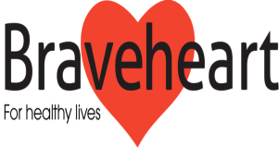

I wish to attend the 13th AGM of the Braveheart Association
on Tuesday 10th October 2017

Name ____________________________________

Address ____________________________________

Phone Number ___________________________________

Email address ____________________________

Designation _____________________________

Falkirk Community Hospital
Majors Loan
Falkirk FK1 5QE
01324 673706

