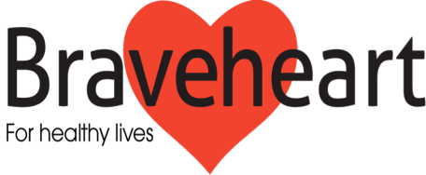

In response to requests Braveheart is running an exciting
fund-raising venture, giving you the chance of winning a cash prize every month.

Friends of Braveheart Draw

The Plan | People buy one or more ‘shares’ per year. Half the total sum raised goes to Braveheart and the other half is distributed on a monthly basis to 2 winning “friends” whose share numbers have been drawn.
Membership | The cost of each yearly share is £ 20 for 12 monthly draws. People may hold more than one share
Shares | Braveheart will allocate a number to each paid share for the 19/20 draws
Prize Draw | All paid share numbers will be included in each monthly draw and prize money will depend on the number of paid-up shareholders

You’ll see that this scheme can raise vital funds for Bravehearts work – it also gives you a chance of winning your money back each month – and more! Your interest in Braveheart, and your support, is greatly appreciated and we hope you will want to take part in this fun fund-raising scheme.

Below is a cut-off application form. Please complete the form and send it, together with a cheque for £20 for each share, to the address below. You can purchase as many shares as you like and the draw will take place on the 30th of each month. The two winning prize numbers will be posted on www.braveheart.uk.net each month and cheques will be posted to the winners.

The closing date for applying for this year’s draw is Friday 28th June 2019

------------- cut here ----------------------------------------------------------------------------------------------------------------------------------------------------

Application to join the Friends of Braveheart Draw

Name: ______________________________________ Phone Number: ______________________

Address: ________________________________________________________________________________

I wish to buy 1, 2, 3… shares, at £20 per yearly share, in The Friends of Braveheart Draw
(Please state number required)

I enclose cash or cheque for £20 per share made payable to
The Braveheart Association
Falkirk Community Hospital
Majors Loan
Falkirk FK1 5QE

Signed: ______________________________ Date: ______________________________

